Student Mental Health Agreement
End of Year Report 2018/19

By
GCU Students’ Association
&
Glasgow Caledonian University

Working areas
Delivering and Developing the Student Mental Health Agreement
- Launch Event for the Student Mental Health Agreement
- Student and Staff Mental Health Survey
Hosting Events on Campus
- World Mental Health Day (10th October)
- University Mental Health Day (7th March)
- Wellbeing Fayre
- Paws Against Stress Event
Delivering Campaigns
- Men’s Mental Health
- Benefits of physical activity on mental wellbeing
- Exam stress
- Student Mental Health Officer and Representation Group
Enhancing and promoting on-campus support services
- Develop a support booklet with every internal support service
- Host a publicity campaign for the Nightline Service
- Continuing ongoing advertisement of Advice Centre and Wellbeing Service
Providing training opportunities for staff and students
- Mental Health Workshop
- Continue the Scottish Mental Health First Aid Award to students
- Continue to encourage participation n in the SMHFA Course for student facing staff
- Mindfulness courses
Enhance peer to peer support networks at GCU
- Preventing and Responding to Gender Based Violence Peer to Peer Training
- Continue our Nightline Service
- Postgraduate Space
- Establish a quiet space on campus
- Social meet up groups
- Free closed yoga groups
- Action for happiness
Review policies and report recommendations at GCU
- Undertake a review of the Mitigating Circumstances Policy at GCU
- Revise the role of Academic Advising
- Enact the report and recommendations from the Student Mental Health Task Group
- Further enhance the wellbeing support available to staff
- Mental health and curriculum – INCLUDE Project

Aims
For each of these working areas what did you set out to achieve at the beginning of the year and why did you choose to focus on this?

Delivering and Developing the Student Mental Health Agreement
- Launch Event for the Student Mental Health Agreement
We intend to launch the Student Mental Health Agreement from 2017/18 to help educate students and staff on the pre-existing support on campus for student mental health, alongside using this as a mechanism to encourage greater student involvement in shaping the actions undertaken in our mental health agreement this year.
The launch event will also be used, alongside other mechanisms such as the Mental Health Workshop to gain extensive and greater student input into the agreement, and will be fed back to a working group with representatives from both the University and Students’ Association who will evaluate the impact of the Student Mental Health Agreement.

- Student and Staff Mental Health Survey
It is essential to ensure that you engage students and staff in the process of embedding new supportive structures into an institution so that individuals with lived experiences of mental health are able to contribute to the support that they would require.
We intended to undertake a mental health survey independently for both students and staff in order to assess the mental health literacy of the population at GCU, and what we could do to help improve both student and staff wellbeing at the university, not only the Student Mental Health Agreement – but other ongoing areas of work including the Mental Health at Work Action Plan, and Healthy Body, Healthy Mind Accreditations.
This will be done for staff through the Mental Health at Work Task Force, and for students through consultation being led the Students’ Association.

Hosting Events on Campus
- World Mental Health Day (10th October)
Young People and Mental Health in a Changing World was the theme of the World Mental Health Day in 2018. World Mental Health Day is observed on the 10th of October every year, with the overall objective of raising awareness of mental health issues and mobilizing efforts in support of better mental health. We aim to create a short online campaign on how students at GCU can keep themselves mentally well.

- University Mental Health Day (7th March)
University Mental Health Day is the national campaign to focus efforts on promoting the mental health of people who live, work and study in Higher Education settings run jointly by Student Minds and The University Mental Health Advisers Network.
The theme this year is ‘Use Your Voice’. Whether you’re a student, a member of support staff, an academic, or a senior university leader, we all have a part to play to cultivate a positive mental health community at university.
We hope to improve students’ and staff's awareness of support and promote a sense of belonging by running workshops and events throughout the 6th and 7th of March.

- Wellbeing Fayre
Each year, we host an annual wellbeing fayre, where we invite external organisations onto campus at GCU Glasgow to distribute information to GCU students on how they can improve their wellbeing. This year, the fayre will be on Thursday 21st March between, 11-3pm.

- Paws Against Stress Event
We aimed to deliver a range of events to help increase student and staff wellbeing at GCU through raising awareness of different coping mechanisms and support available.
“Conner and Miller (2000) state that for many years, the therapeutic value and importance that animals have in the spiritual and secular lives of people have been observed. Lutwack-Bloom et al (2005) document an extensive history of pet therapy dating back to 1792. In addition, Stanley-Hermanns and Miller (2002) and Ormerod (2005) state that in the mid 1800s, Florence Nightingale understood the therapeutic value of pets and encouraged her patients to care for animals.”
After previous success hosting a Paws Against Stress Event on Campus with Canine Concern Scotland, we aim to host another event throughout the academic year to engage students with the positive impacts of Therapets.

Delivering Campaigns
- Men’s Mental Health
We know from academic research that males are disproportionally impacted by the impacts of mental health than females. In the UK 3 out of every 4 suicides are by male individuals, and suicide is the biggest killer of men under the age of 45.
Time to Change state that:
“We carried out research into men’s and young people's attitudes towards mental health over the course of a year, which included feedback from 18 focus groups across the country.

This new insight revealed a number of barriers preventing men in particular from opening up to the topic of mental health. Compared to women, men are:
- Less knowledgeable about mental health, with more negative attitudes
- Far less likely to report their own experiences of mental health problems and less likely to discuss mental health problems with a professional
- More likely to say that mental health problems are the result of a ‘lack of self-discipline and willpower’
- Three times more likely to take their own lives than women with suicide being the leading cause of death in men under 45.”
At GCU, while self-identifying males comprise 42% of the student population, they only make up 31% of enquiries into the counselling and advice services at the university (2017/18 – F 403, M185). Thus, there is local evidence that supports the conclusions drawn above that gender, and more specifically the current conception of masculinity, influences uptake of mental health support services.
To help address this and enable our male students to access mental health support services, the Students’ Association and GCU reached out to the Men’s Mental Health Charity CALM (Campaign Against Living Miserably) to tailor a seminar session for students at GCU on the impacts of mental health on men.

- Benefits of physical activity on mental wellbeing
We aim to host a campaign on campus to raise awareness of the positive impact being physically active can have on mental health and wellbeing, to support and encourage daily activity to enhance mental wellbeing on campus.

- Exam stress
We recognise that examinations can be an unusually stressful time for students, and at GCU we wanted to help support students through this by hosting a campaign during this period to promote awareness of on campus support services, and ways for students to maintain their wellbeing through self-care.

- Student Mental Health Officer and Representation Group
We aim to establish a part time representation officer to support the Students’ Association, Full Time Officers, and University in campaigning for Student Mental Health and wellbeing. The officer will feed into a wider representation group on mental health, and be able to ensure student views are at the centre of the project.

Enhancing and promoting on-campus support services
- Develop a support booklet with every internal support service
We hope to finalise a booklet which outlines every support service available to GCU students on campus, as well as out of hours’ contacts, in one easily accessible and understandable booklet. The booklet would then be implemented on a tab on GCU Learn. This would make the information visible, and accessible to all students.

- Host a publicity campaign for the Nightline Service
The Nightline service is currently advertised through Plasma Screens around campus, and on the university and Nightline Association websites. The service itself has a publicity officer for each university who helps to organise Nightline Awareness Week in Trimester 1; and publicity campaigns throughout the academic year.
We aimed to continue this effort, and specifically work to enhance the publicity campaign undertaken for the service. This occurred throughout “Nightline Awareness Week”

- Continuing ongoing advertisement of Advice Centre and Wellbeing Service
Currently, there is a focus from the University and the Students’ Association to continue effectively advertising these services to students. This occurs in several ways such as leaflets, through online webpages, in all student emails and in social media. These methods, and more, will be demonstrated in the final report for the Student Mental Health Agreement.
It is hoped that these advertisement methods could be expanded in ways such as Sabbatical Officer social media posts, lecture shouts, the support booklet and GCU learn support tab.

Providing training opportunities for staff and students
- Mental Health Workshop
We wanted to work to increase the knowledge and understanding of students on what support GCU and GCU Students’ Association provide for student mental wellbeing, and improving our student’s mental health literacy. This is why we’re working to develop and deliver a workshop on mental health at both of our academic representative gatherings this academic year.

- Continue the Scottish Mental Health First Aid Award to students
The SMHFA is recognised by the NHS, and is a great opportunity for students to learn how to greater support their peers at university.
Last year, the course was introduced to the GCU Glasgow Campus free of charge to students through embedding it into our Student Leaders Programme. Courses will continue into the 18/19 Academic year, and be promoted for students to attend.

- Continue to encourage participation n in the SMHFA Course for student facing staff
The Scottish Mental Health First Aid Award is a course which aims to equip individuals with the skills to help someone in distress in the same way a first aid certificate can help educate those in assisting those in physical distress.
The skills and abilities taught in the course may assist student facing staff in supporting distressed students, and as such we aim to increase the number of staff who have received the training and achieved the award throughout the 18/19 Academic Year.

- Mindfulness courses
Mindfulness meditation offers simple yet powerful techniques that can be incorporated into our daily lives to help us cope with stress and increase feelings of contentment, and numerous studies have found that regular practitioners can experience a decrease in anxiety, low mood and irritability, better and more fulfilling relationships, lower levels of stress, a reduction in the impact of serious conditions such as chronic pain and an improved immune system.
As such, at GCU we’re aiming to continue offering free mindfulness sessions to GCU Students.

Enhance peer to peer support networks at GCU
- Preventing and Responding to Gender Based Violence Peer to Peer Training
Throughout the past two years the university and Students’ Association have been working to provide a free programme for students which aims to challenge sexual violence in society. Students will be trained and supported to deliver workshops in which issues such as consent, how the media portrays gender-based violence, and other topics will be discussed with other students in a safe environment.

- Continue our Nightline Service
Nightline is a confidential listening and information service run by and for students of Glasgow Strathclyde and Caledonian Universities. The service operates from 7pm-7am, Monday-Friday during terms time.
The service requires student volunteers each year, who the Students’ Association trains and supports in both trimester 1 and 2, and then help to facilitate a rota in which students can sign up to support their peers. We are committed to continuing this service throughout the 2018/19 academic year, and increase student awareness of this.

- Postgraduate Space
In previous feedback from our Postgraduate Students, we found that they often reported that they felt isolated on campus and didn’t have a sense of social community. We aim this year to establish and open a post graduate space for students to study and socialise in to help build a sense of community.

- Establish a quiet space on campus
We recognise that students and staff at Glasgow Caledonian University could benefit from a quiet space on campus to individuals to reflect quietly and take some time out to de-stress and relax. We aim to establish a space on campus in the 2018-19 Academic year to enable this.

- Social meet up groups
This year the Wellbeing Service is pleased to introduce a new informal programme of activities for students to take some time out to focus on their health and wellbeing. This will be a good opportunity to make friends and develop new skills in a relaxed environment.

- Free closed yoga groups
We aim to continue a partnership with our on-campus University Gym in which the Wellbeing Service are able to refer students to attend a free, closed Yoga Group to help them build their confidence to attend another classes at the gym, and benefit from the positive impacts of physical activity, whilst also gaining a sense of community.

- Action for happiness
This year at GCU, we’re also aiming to introduce an 8-week course to campus called Action for Happiness. The Course is run by local volunteers, and gives individuals the ability to meet friendly, like-minded people, and come together to find simple ways to improve the happiness of both the individual attending, and others.

Review policies and report recommendations at GCU
- Undertake a review of the Mitigating Circumstances Policy at GCU
Conduct a review in the University of the current Mitigating Circumstances Policy, and how this interacts to support applications from students in relation to mental health.

- Revise the role of Academic Advising
To conclude the review of the Academic Advising model, and implement recommendations to re-brand the model to Personal Tutoring in order to enhance a culture of supporting students holistic throughout their studies. Host a publicity campaign for the new model to increase staff and student awareness of the support network.

- Enact the report and recommendations from the Student Mental Health Task Group
To carry forward and implement the recommendations from the Student Mental Health Task Group within Glasgow Caledonian University. This includes the appointment of an additional Mental Health Adviser within the GCU Wellbeing Service to help provide enhanced support for GCU Students. The Task Group also recommended the introduction of a GCU Student Wellbeing Advisory Group to oversee the on-going development and monitoring of progress against the Student Mental Health Action Plan.

- Further enhance the wellbeing support available to staff
Establish a Mental Health at Work Task Force and produce an Action Plan with recommendations on how staff can be supported at Glasgow Caledonian University to ensure that staff are able to encourage a culture of wellbeing at GCU.

- Mental health and curriculum – INCLUDE Project
We recognise that certain points in the academic year and engagement in certain curricular activities may be more stressful for students than others, and as such we wanted to explore what these may be, and if there is anything, we can do to mitigate these for students.

The INclusive CUrriculum DESign (INCLUDE) project aimed to examine the way in which curriculum at GCU is structured and produce recommendations that could help improve student wellbeing and ensure an inclusive curriculum. The overall goal of the project is to build the capacity of academic staff to design curricula and create teaching and learning environments that are inclusive and promote student mental wellbeing.

Key drivers for the project included:
- GCU Mental Health Action Plan & SfL 2015-20 (FAIR Curriculum);
- GCU SEAP 2020 (Objectives 1.1-1.3; 2.2, 2.3; 4.1-4.1);
- Universities UK’s Mental Health Framework
- NSS Qs 15, 21, 23-25
- Student Minds research report (2018)

Project Activity
For each working area provide a summary of activity across the year, including key dates, events and links to any relevant information. Please provide pictures wherever possible.

Delivering and Developing the Student Mental Health Agreement
- Launch Event for the Student Mental Health Agreement
We initially worked to publish the Student Mental Health Agreement to our website at https://www.gcustudents.co.uk/advice-centre/student-mental-health-agreement to increase awareness of the agreement. Following this, on the 25th of April we worked to launch the Student Mental Health Agreement to GCU Students and Staff. The event included presentations from the Student President, Principal and Vice-Chancellor, Deputy-Vice Chancellor Academic, and a GCU Alumni who is now the Chief Executive of a mental health charity (LifeLink) on the importance of supporting individuals in the community, in education, and specifically GCU.
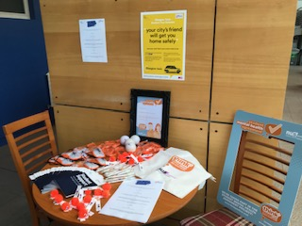
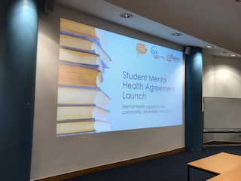
Also featured at the event was the launch of the re-developed Safe Taxi Scheme, and the Student Support Booklet (See on later in this evaluation document).
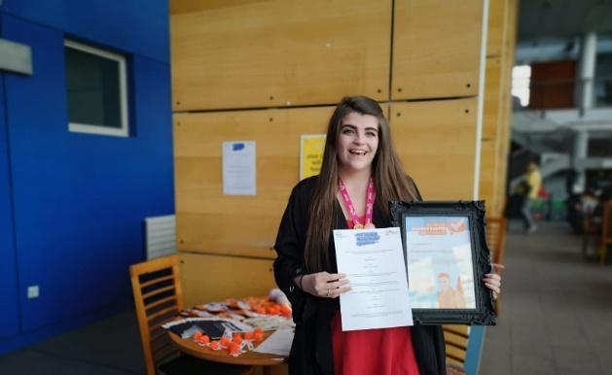
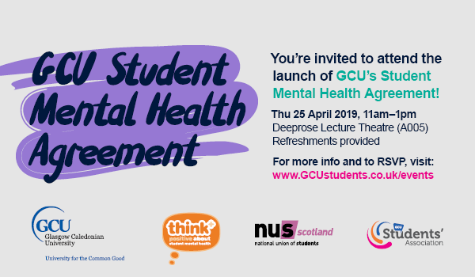

See more information at the events pages at:
https://www.facebook.com/events/2241785542750020/

And more pictures from the event at:
https://www.facebook.com/pg/GCUstudents/photos/?tab=album&album_id=10156767560425642

The event was communicated out through various platforms, including an article on our Universities Intranet, Caledonian Connected.

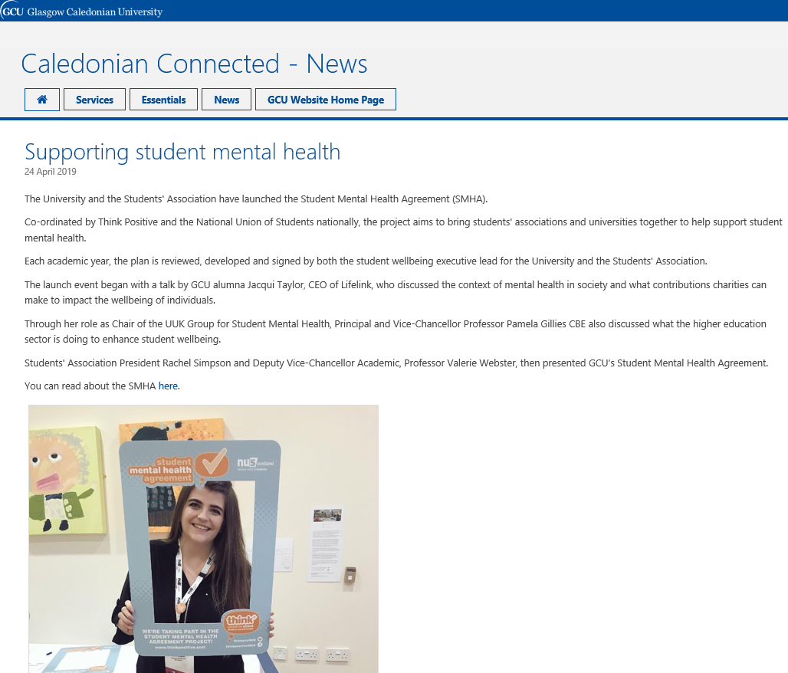

- Student and Staff Mental Health Survey
Students
One way in which we consulted students was through an online survey. Other methods included through a Mental Health Workshop (see below in evaluation document) and through updates at our Student Voice Committees.
The Survey looked at various areas of student wellbeing, such as mental health, smoking on campus and physical activity
Link to survey: https://www.surveymonkey.co.uk/r/GCUStudentSurvey?fbclid=IwAR0QxfmQPgs-OuSPsqmJ1IbOGTlfDnHwkaVNoBU6l1m1GiiiDM1sxBUPZjM
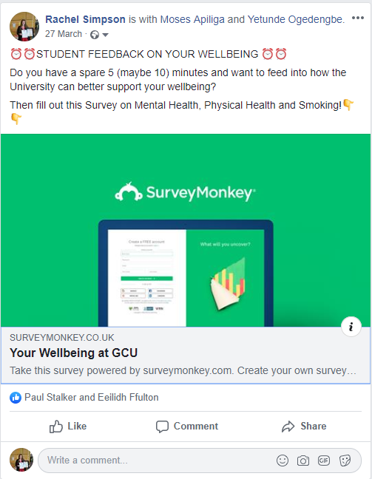

Staff
Staff too were given the opportunity to feed into the ongoing work of the Mental Health at Work Taskforce through consultation focus groups, and through an online survey.
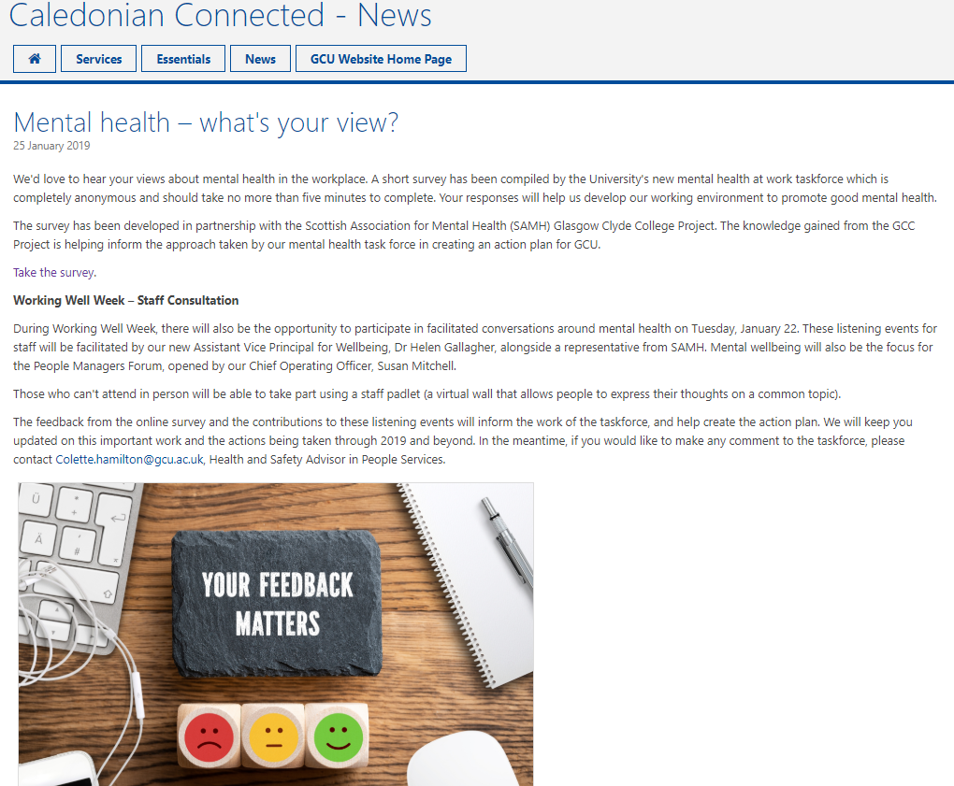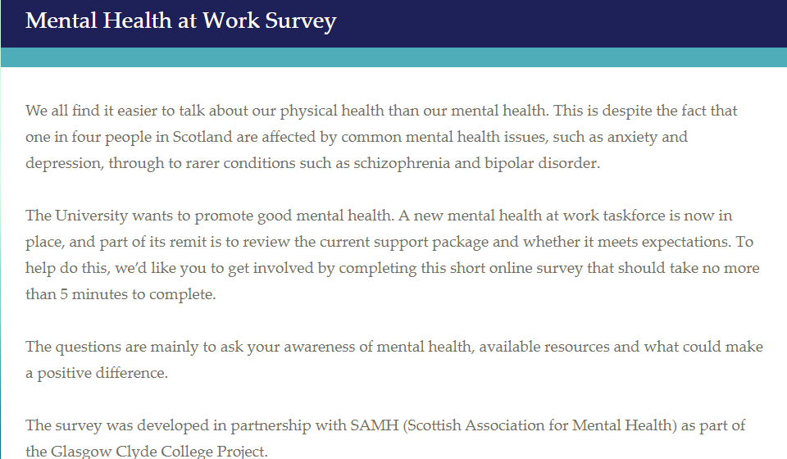

Hosting Events on Campus
- World Mental Health Day (10th October)
During World Mental Health Day we organised for a range of social media promotions alongside a video from our student communications team to be shared to engage with GCU Students. Moreover, our student radio station Radio Caley also produced a video on WMHD to help raise awareness of on campus support.

Social Media Posts –
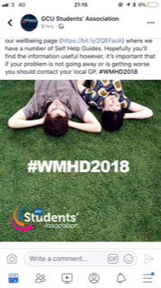
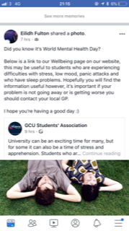
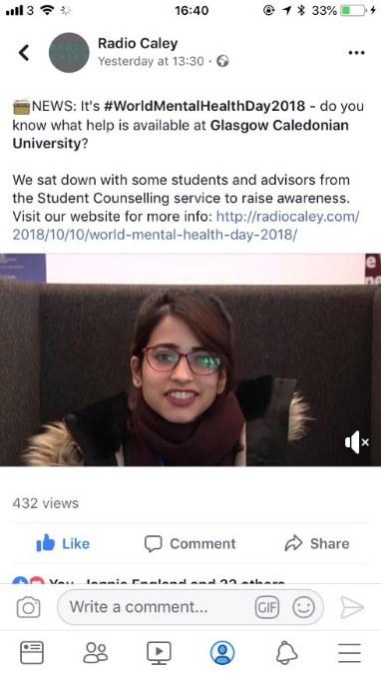

Videos available here: https://www.facebook.com/radiocaley/videos/316252562259518/
https://www.facebook.com/gcustudentwellbeing/posts/2126636460907751

- University Mental Health Day (7th March)
The Student Wellbeing Service worked with various partners across the university, including the Student Association, the School of Health & Life Sciences and the Trade Unions to raise awareness and challenge the stigma around mental health. There were a range of activities for students on campus, including workshops, free guided bike rides, mindfulness sessions, and more! The events ran over two days to help increase the number of students who could engage with the events.

Schedule for events:
Wednesday, 6 March 2019
12:30-13:00
Cycling for Wellbeing - Chat with Mike Kemp, Cycling Officer about cycling and bike maintenance opportunities. CEE Foyer
13:00-15:00
FREE guided bike ride with FREE hire bikes available - Meet outside Security Office - Contact Mike Kemp for info.
14:00-15:00
Mindfulness Taster Session - No special clothing required - W007
14:00-16:00
Staff coffee break with GCU Trade Unions in Staff Social Space
15:00-16:00
Acknowledging and Managing Stress Workshop (Psychology trainee) Campus Life Seminar Room 1

Thursday, 7 March 2019
10:00-11:00
Find out about the University’s Mental Health Action Plan and the roles within the Wellbeing Team - CL Seminar Room 1
10:00-14:00
Relaxation Room - Free Reiki Tasters, Chill-out space, herbal tea and doodles! Campus Life Seminar Room 2
11:00-12:00
Negative Thoughts & CBT Workshop (Psychology trainee) CL Seminar Room 1
12:00-13:00
Lunchtime Ted Talks - Stress, procrastination etc. drop in with your lunch - CL Seminar Room 1
13:00-14:00
Relaxation Techniques Workshop (Psychology Trainee) - CL Seminar Room 2
14:00-15:00
Knitting and Crocheting and Chatting! - Drop-in and have a go! Campus Life Lounge
14:00-15:00
Mindfulness Taster - No special clothing required - CL Seminar Room 1
15:00-16:00
Self-care: From Apps to Maps: Demo of some apps to help you plan and manage your workload - CL Seminar Room 1

Social Media Promotions of events –
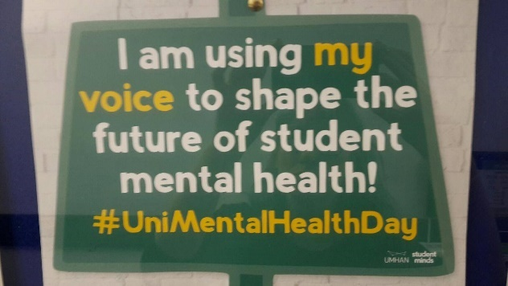
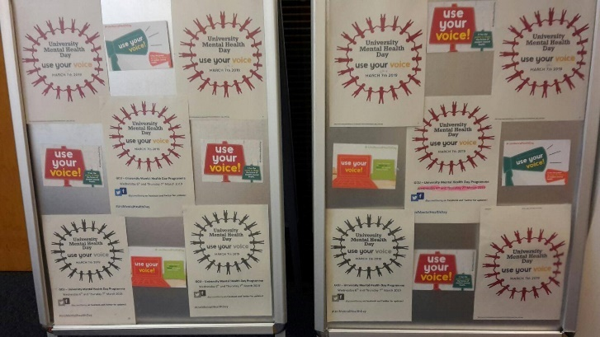
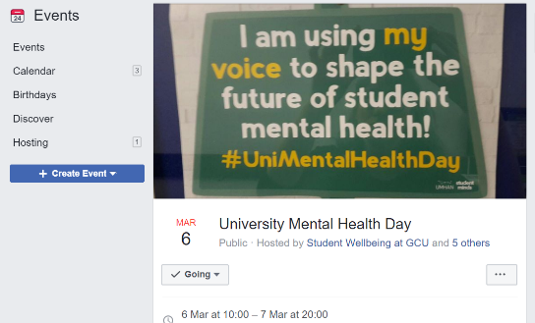
https://www.facebook.com/events/240213806907952/
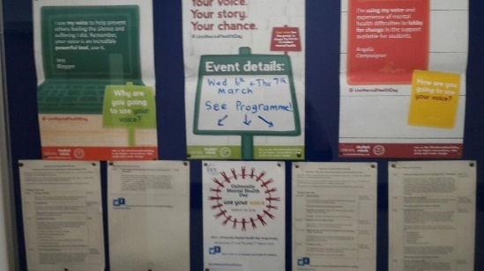
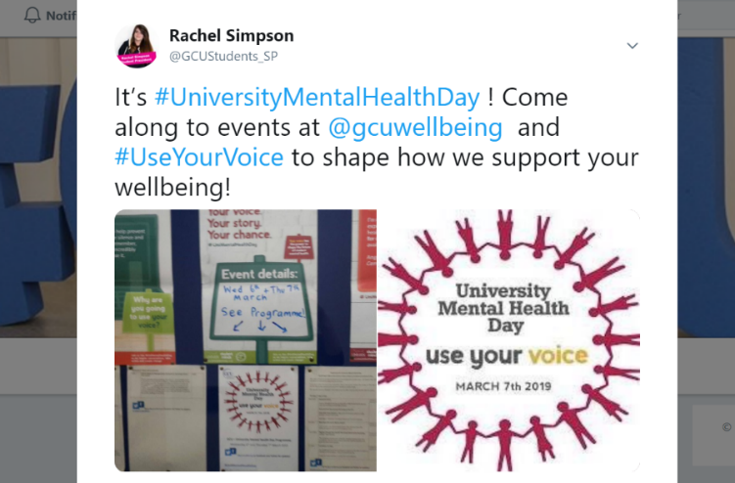

- Wellbeing Fayre
Throughout the academic year, the Students’ Association host a programme of Wellbeing campaigns and complete the programme by providing an annual Wellbeing Fayre where Students and Staff can find lots of information on a variety of topics; activities and freebies for all students.
This year the fayre was on Thursday 21st March and was attended by over 100 students, and there were 10 stalls on a range of topics; sexual health, mental health, oral hygiene, alcohol awareness, personal safety, nutrition and cycling and environment and keeping fit. 20 free massages were given, as well as henna tattoos throughout the course of the fayre, a smoothie cycle activity was available throughout the fayre, and a rowing competition was also available with prizes from the Arc gym. Over 100 pieces of fruit were distributed by the Nutrition and Dietetics Society, and on campus support services were promoted throughout the day via a stall.

More information can be found on the event page at:
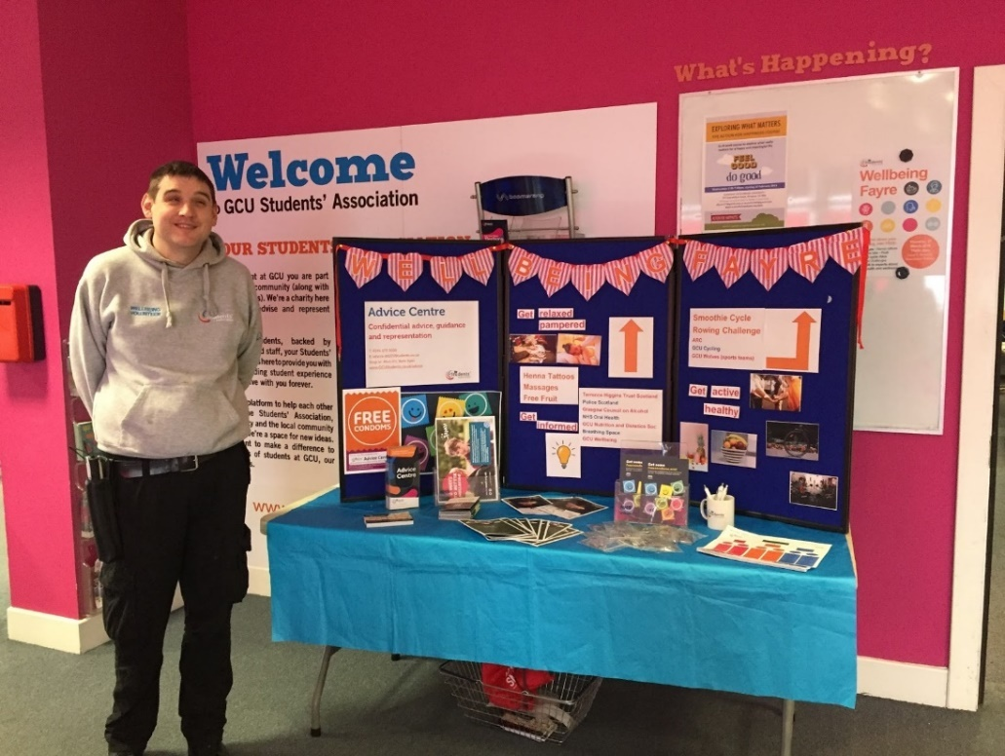
https://www.facebook.com/events/1239993386163098/

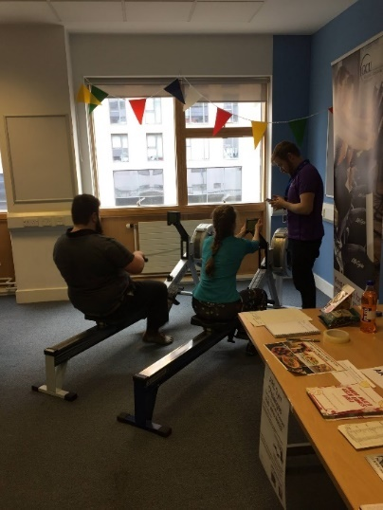
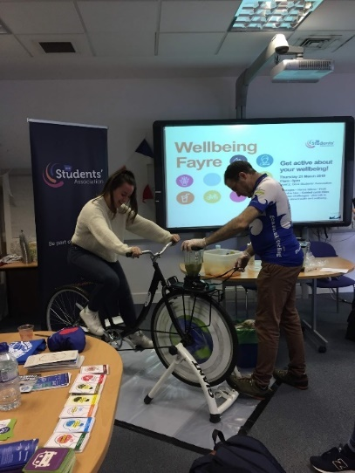

- Paws Against Stress Event
On the 1st of May 2019, the University Wellbeing Department hosted a Paws Against Stress event on campus to help enhance the wellbeing of students and staff on campus.

https://www.eventbrite.co.uk/e/paws-against-stress-1st-may-2019-registered-gcu-students-only-tickets-47989587147
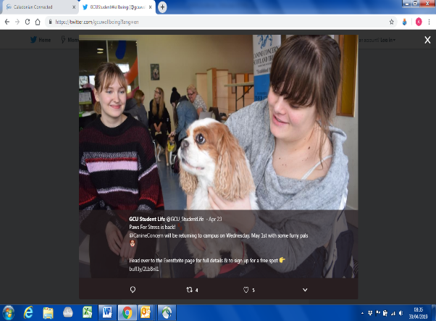
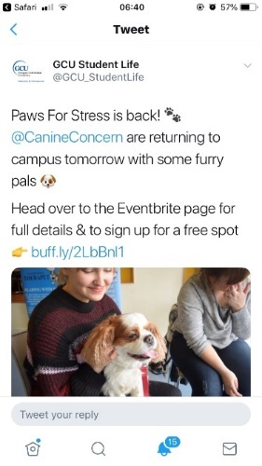

Delivering Campaigns
- Men’s Mental Health
Initially we had aimed to work in partnership with CALM to provide a contextualised seminar for GCU Students on mental health. Unfortunately, they were unable to come onto campus, however this made us reconsider how we deliver this work.
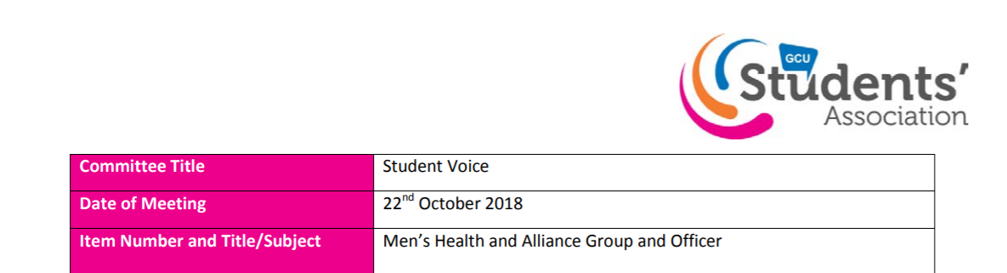
Consequently we focused our efforts into the establishment of a specific Men’s Health and Alliance Student Officer at GCU Students’ Association, who in partnership with the Student Mental Health Officer, will work together to break down stigma or barriers surrounding mental health and develop student led campaigns throughout the following academic year.

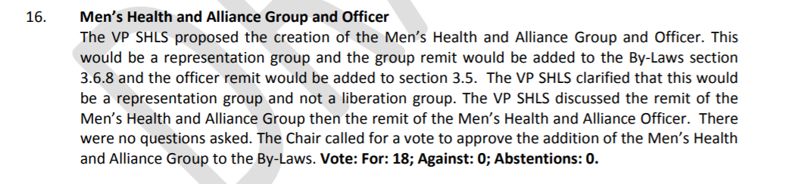

More info:
https://www.gcustudents.co.uk/papers
https://nusdigital.s3-eu-west-1.amazonaws.com/document/documents/44817/f7f00d6c7a43e500cc48f70f45a36872/Mens_Health_and_Alliance_Group_and_Officer_SV_22-10-18.pdf

- Benefits of physical activity on mental wellbeing
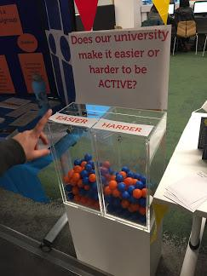
In order to raise awareness on campus of the positive impact being physically active can have on mental health and wellbeing, to support and encourage daily activity and to enhance mental wellbeing on campus, GCU Students’ Association through their Wellbeing Volunteer Programme dedicated a campaign to the links between Mental health and Physical Activity.
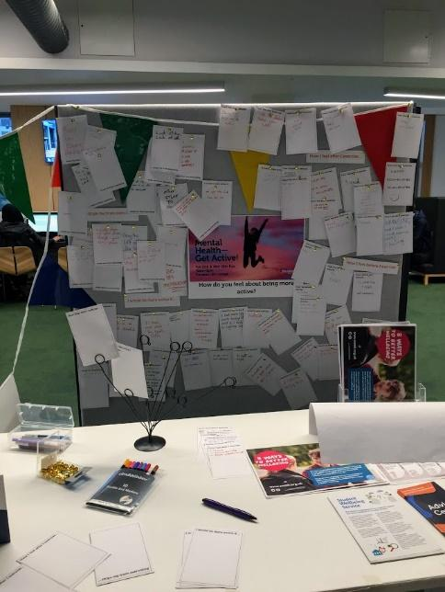
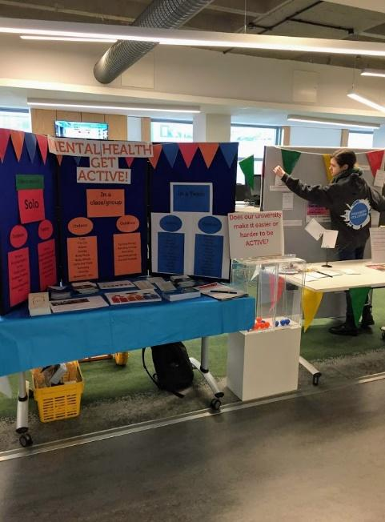
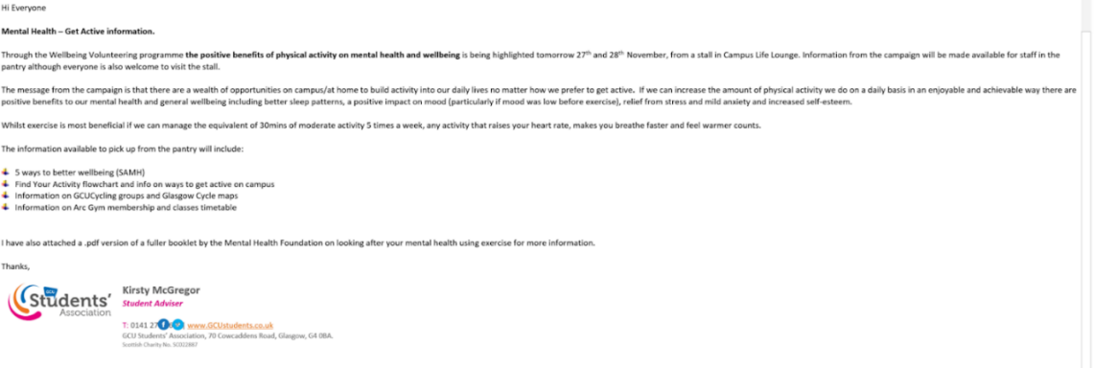

- Exam stress
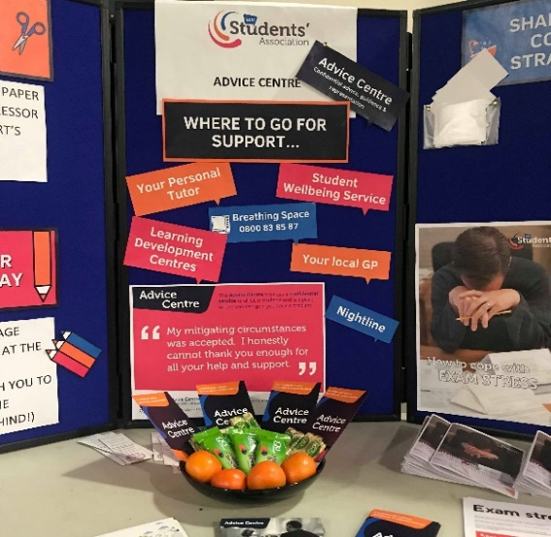
Throughout the exam period in December the GCU Students’ Association Advice Centre offered an Exam’s Stress Stall outside of the 24 hour lab which engaged students with self-help resources, information on what support was available on campus, and free fruit.
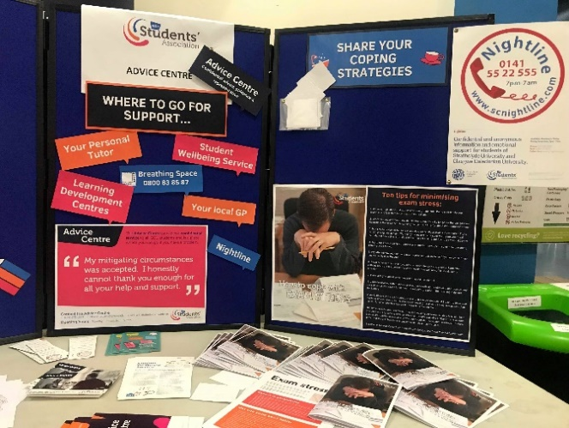

- Student Mental Health Officer and Representation Group
To ensure that our work on student mental health continue to be student-led, sustainable, and a holistic approach was taken between the ongoing work on student wellbeing (SMHA, HBHM, etc.) GCU Students’ Association also established a specific student officer and representation to campaign on student mental health and wellbeing,
The proposal was approved by our student voice on the 11th of February 2019.
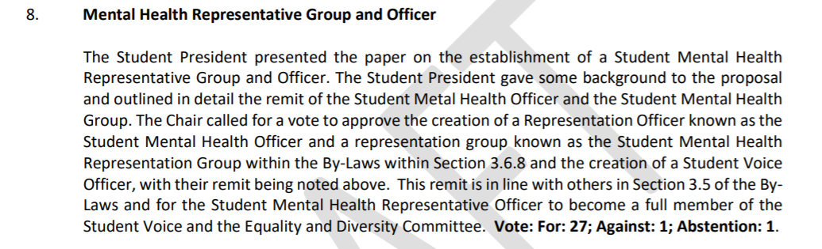
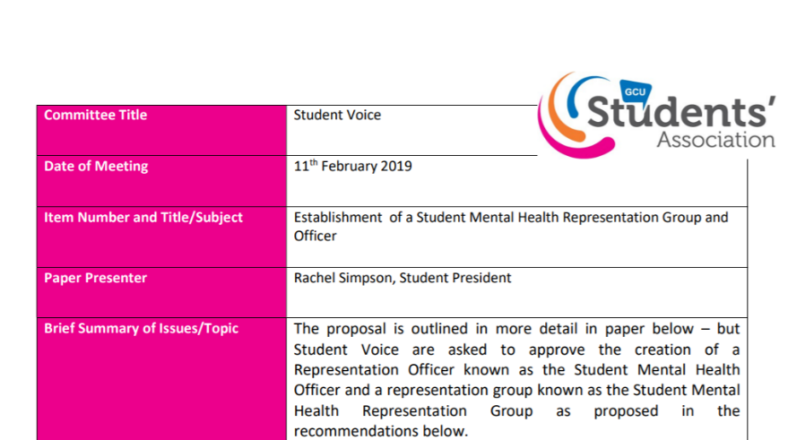

https://nusdigital.s3-eu-west-1.amazonaws.com/document/documents/46597/Mental_Health_Representation_Group_Voice_Paper.pdf

Enhancing and promoting on-campus support services
- Develop a support booklet with every internal support service
The Student Support Booklet was formalised and printed in March 2019, and launched officially at the Student Mental Health Agreement launch on the 25th of April.
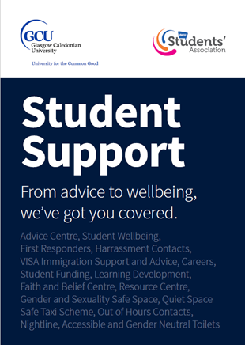
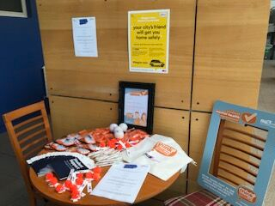

The booklet is also available online at:
https://www.gcustudents.co.uk/advice-centre/student-support-booklet

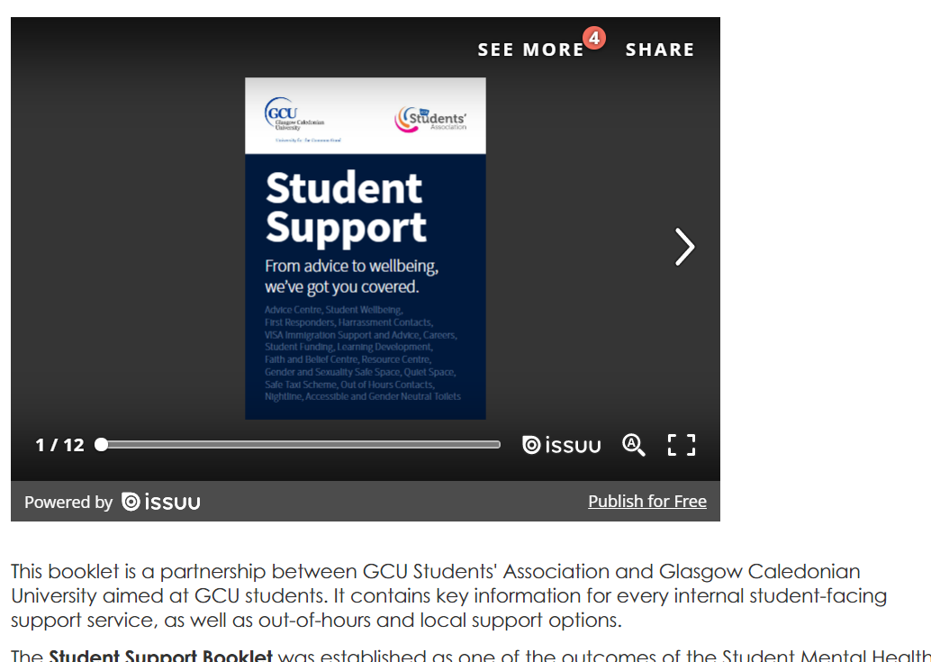

- Host a publicity campaign for the Nightline Service
Nightline Awareness Week in November included a series of events which included the creation of posters conveying the key ethos of the Nightline service, physical stalls around campus, online and physical communications through social media and posters, pottery paining event for volunteers and the distribution of enamel badges to students and staff around campus to spread awareness of the service!
During NLAW a Nightline volunteer wrote an article in THE EDIT about their experience volunteering for the helpline, which gathered much support.
http://www.theeditgcu.com/news-features/nightline/?fbclid=IwAR0DIcs72Nu-G77FUUqOlGJbWCpmKp0tcl8L5d9JeDzZXZh-5xSP81iJr1s
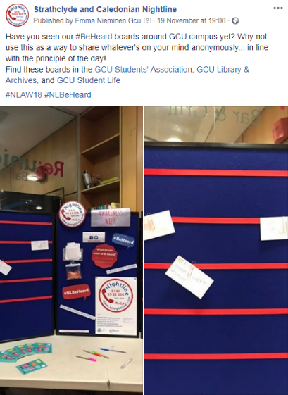
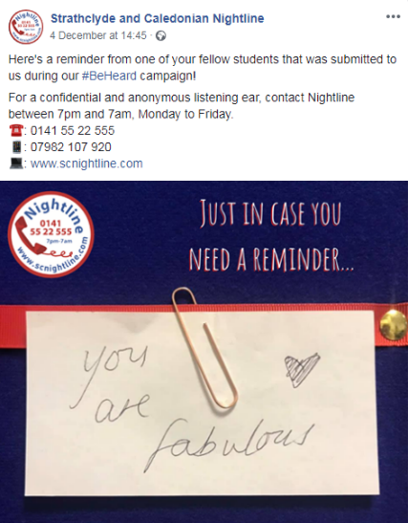
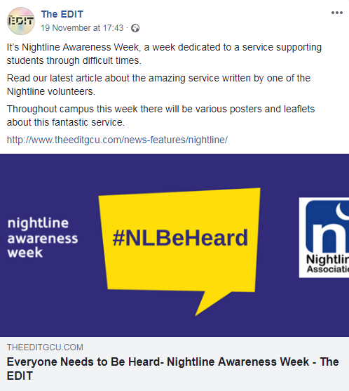
A GCU Digital Design student called Ashleigh Robertson kindly created a video as part of her course showcasing the impact of mental health difficulties, which signposted to Nightline as a source of support. This was widely shared on Nightline’s social media platforms.
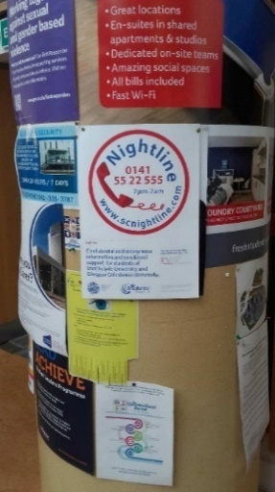
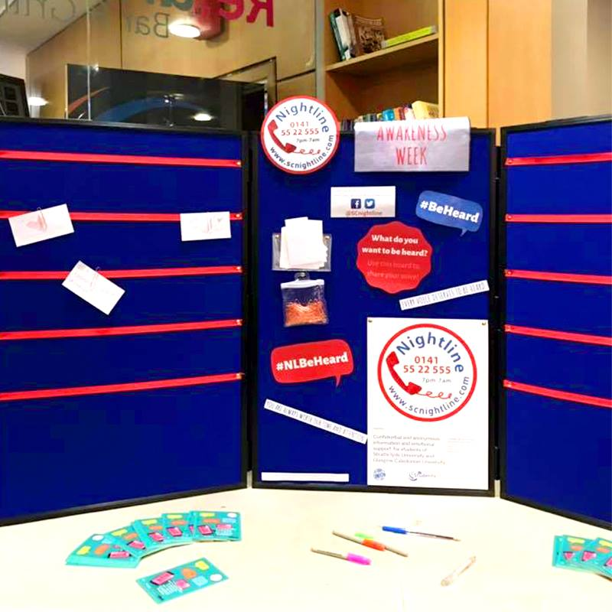
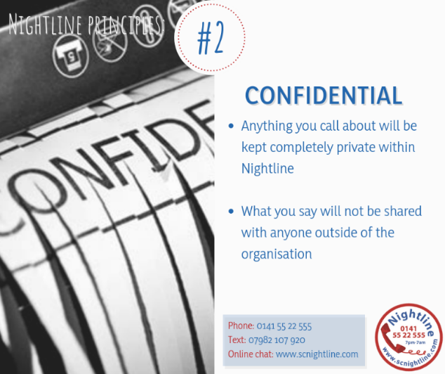

- Continuing ongoing advertisement of Advice Centre and Wellbeing Service
GCU Wellbeing Service
The wellbeing service in the university continue to publish leaflets, online campaigns, and resources for students to learn about the support provisions available.
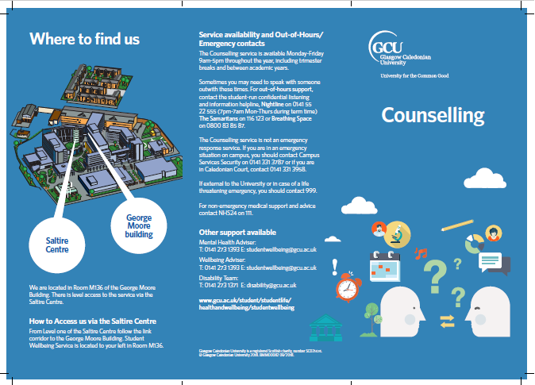
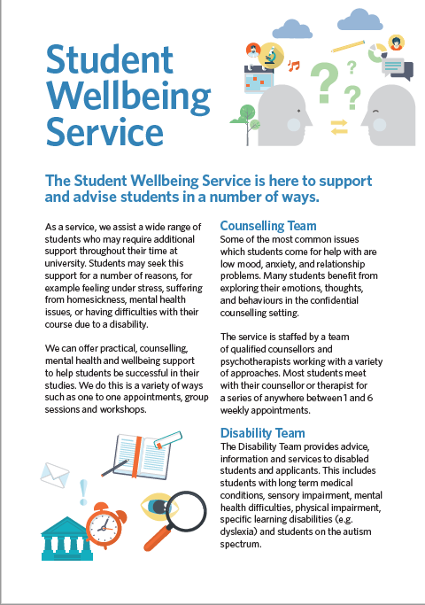

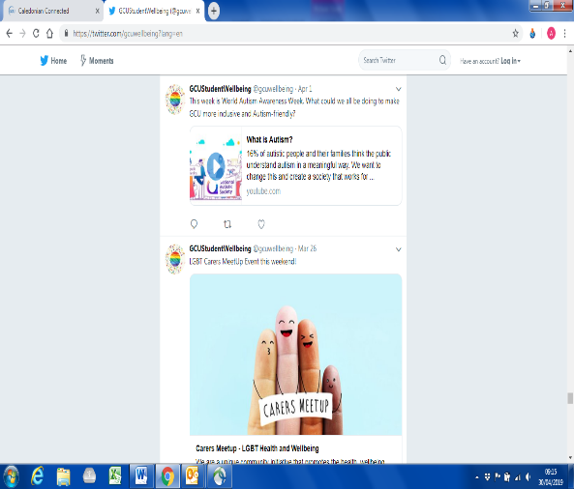
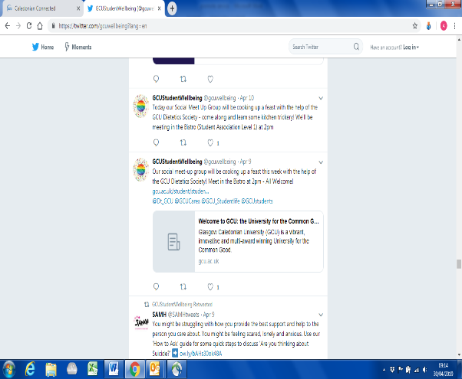

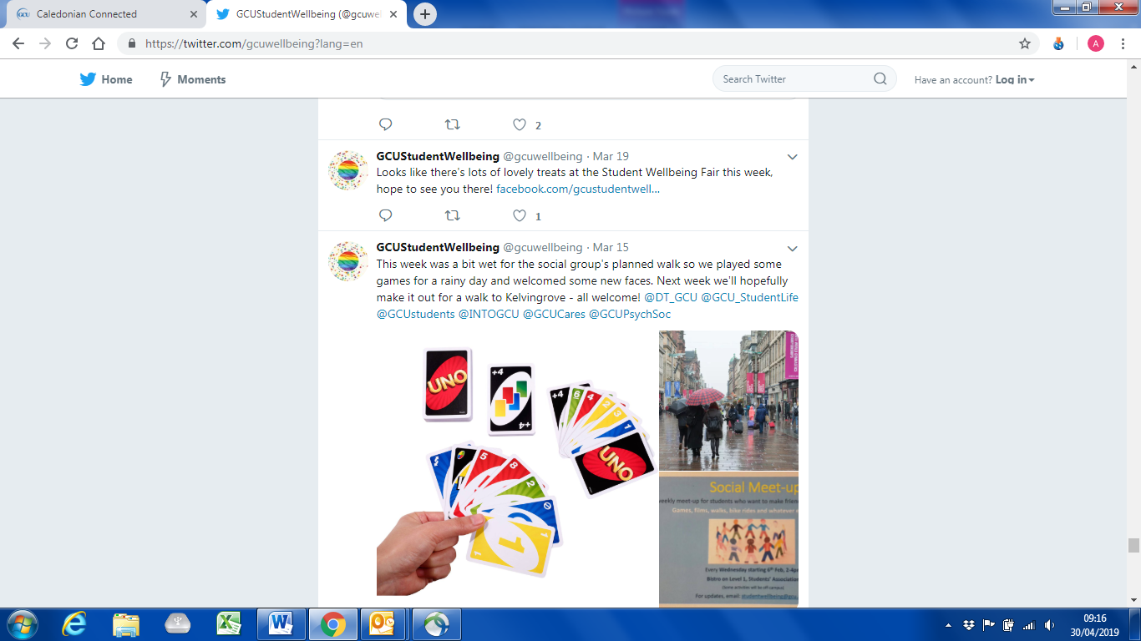

GCU Students’ Association Advice Centre
The Advice Centre has also continued to publish leaflets, produce online material, and was featured in a blog and social media posts regarding wellbeing provisions.
https://www.gcustudents.co.uk/articles/supporting-your-mental-wellbeing

Social media:
https://www.facebook.com/GCUstudents/photos/a.458651080641/10156449247045642/?type=3&theater

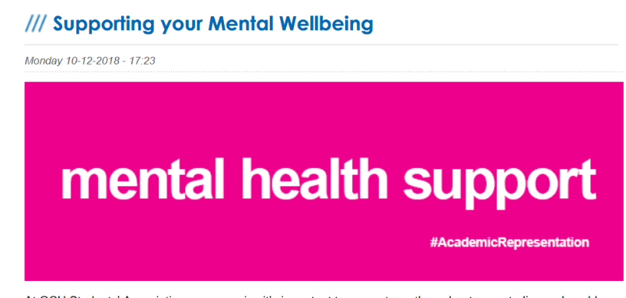
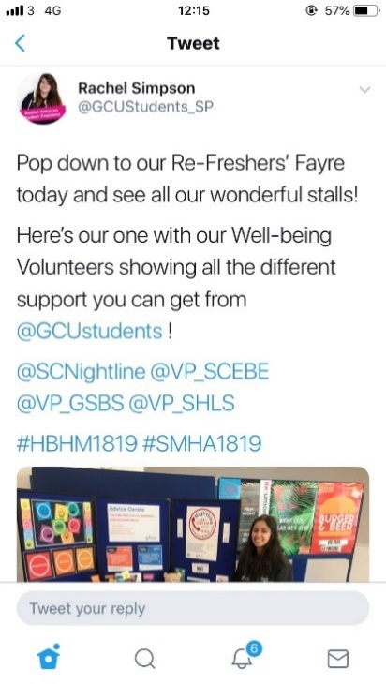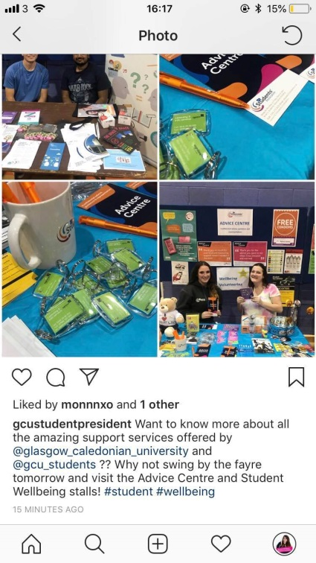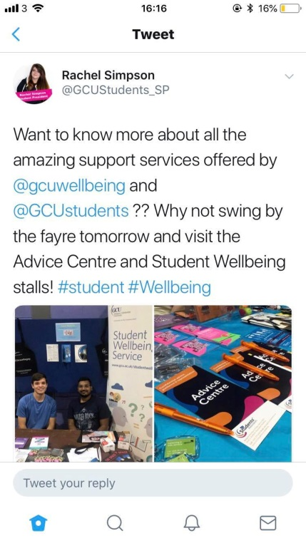

Both services also partook in the student services fayre on the 8th of October 2018.
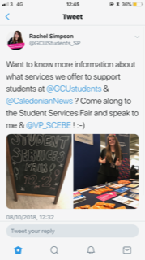
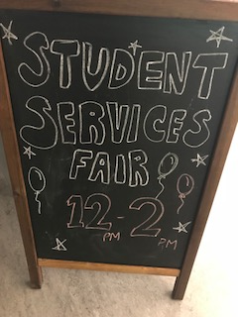
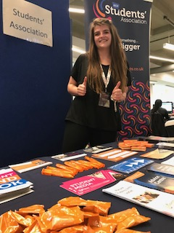

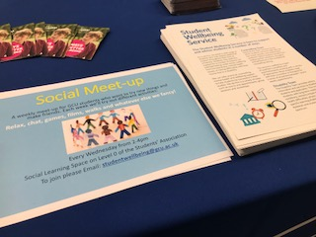
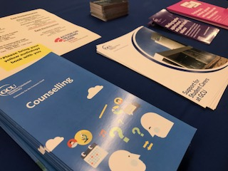

Providing training opportunities for staff and students
- Mental Health Workshop
The Student President delivered a workshop on mental health as part of the Trimester A and B Academic Rep Gatherings.
The workshop looked at statistics both at GCU and in the sector on mental health, and the disproportionate negative impact we can observe in the student population. Studies have stated that up to 78% of Students experienced mental health concerns whilst in higher and further education, and up to 80% of students experienced stress, 55% reported feeling anxiety, and 49% reported feeling depressed.
This focused on gathering input from our academic representatives into the work we’re doing to support student mental health at Glasgow Caledonian University and GCU Students’ Association through our Student Mental Health Agreement, and as such our Healthy Body, Healthy Mind Award.
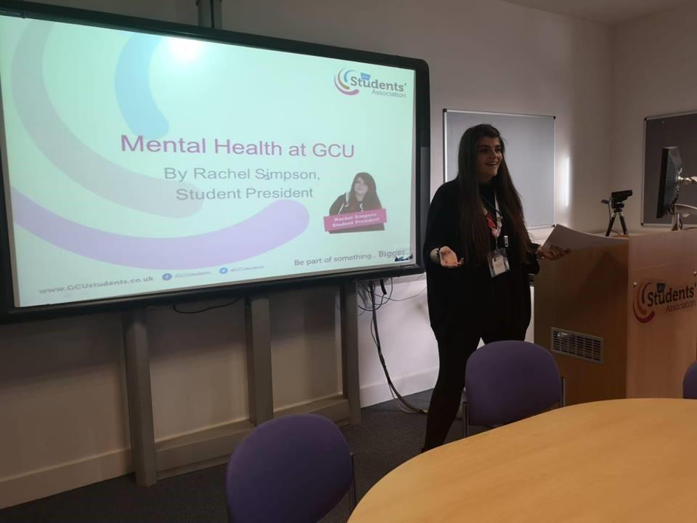
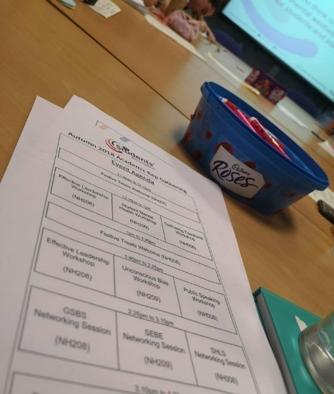
https://www.gcustudents.co.uk/articles/student-mental-health-workshop

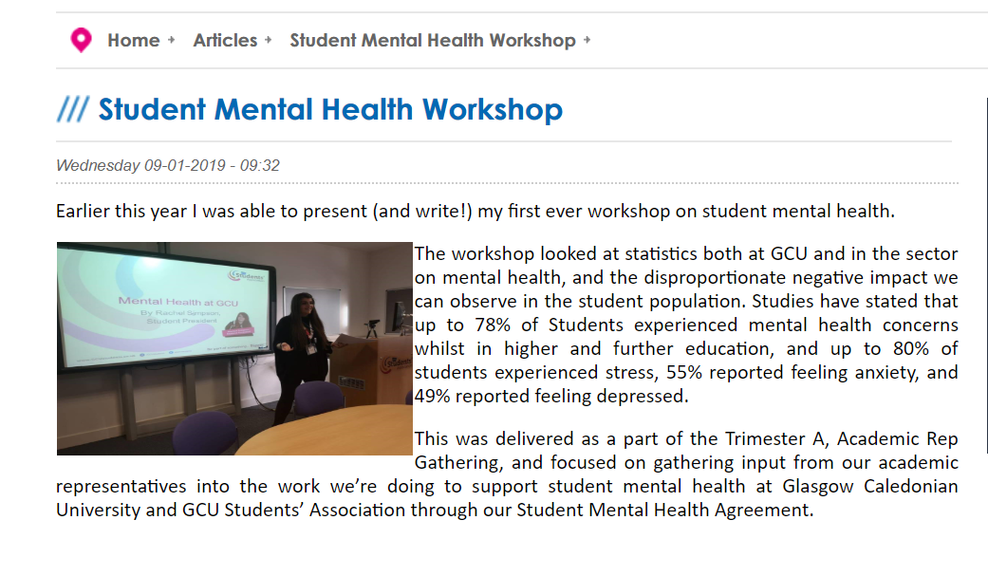
- Continue the Scottish Mental Health First Aid Award to students
Scottish Mental Health First Aid Training was carried out on the following dates:
- Trimester 1: 15th and 22nd November 2018 from 9:30am to 4pm on both days.
- Trimester 2: 7th and 14th March 2019 from 9:30am to 4pm on both days.

In order to complete the training students had to attend both days of training in full. After attending both days of training students then received their certificate of attendance and accreditation. Across these dates 28 students participated and received their certificate of attendance and accreditation.
More information on the training and what the session includes can be found on the link below:
https://www.gcustudents.co.uk/activities/student-leaders-programme/external-workshops
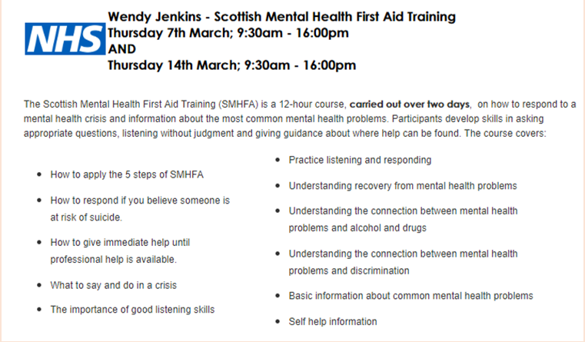

The above image gives information about the different area in which the course covers. This information was readily available to students wishing to take part in the course.

- Continue to encourage participation n in the SMHFA Course for student facing staff
We sent two members of staff to be trained in the Scottish Mental Health First Aid Award training provided by NUS Scotland.
- Rachel Simpson (Student President GCU Students’ Association)
- Kirsty McGregor (Student Advisor, GCU Students’ Association)
We had also booked for a member of the University Disability Team to also attend the training session, however due to unforeseen circumstances they were unable to attend the training.
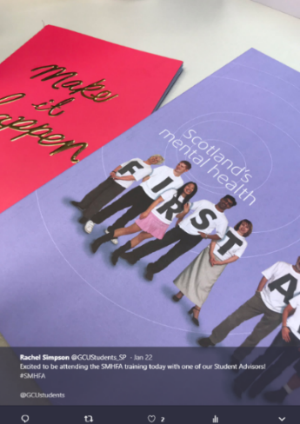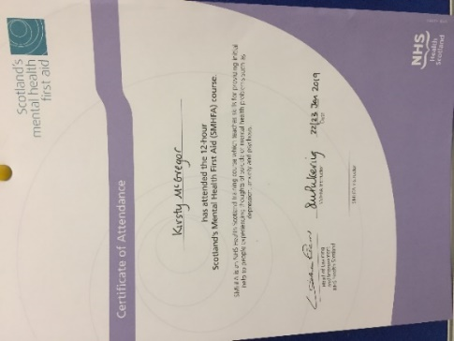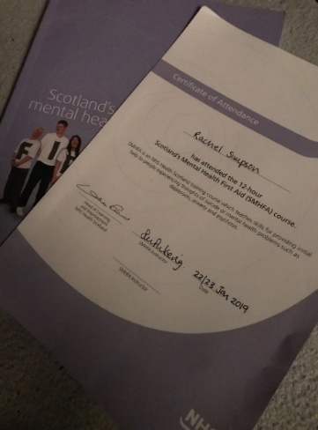

- Mindfulness courses
GCU Staff who were also accredited mindfulness practitioners offered an 8 Week Course to GCU Students alongside a taster session beginning from the 3rd of October.
https://www.gcustudents.co.uk/articles/gcu-student-mindfulness-taster-session-and-8-week-course

The idea of increasing our mindfulness provision for GCU students was also discussed at our Student Voice committee and passed into policy. More information on this can be seen here:
https://www.gcustudents.co.uk/articles/your-ideas-into-action-mindfulness-sessions

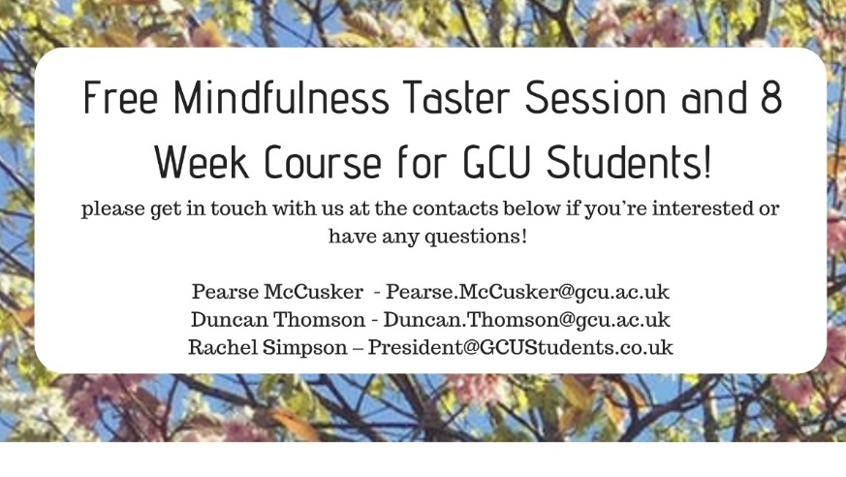
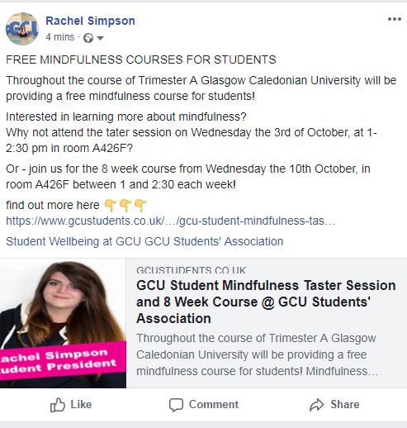

Enhance peer to peer support networks at GCU
- Preventing and Responding to Gender Based Violence Peer to Peer Training
The workshops continued to be delivered throughout the academic year by two student trainers and were co-ordinated by the Student President and SA Staff. The workshops help to challenge misconceptions around GBV, explain the criminal justice system, and educate students on the support available at the Glasgow Campus.
More information can be found on the specific content delivered as part of the training by clicking on the link below:
https://www.gcustudents.co.uk/activities/student-leaders-programme/external-workshops

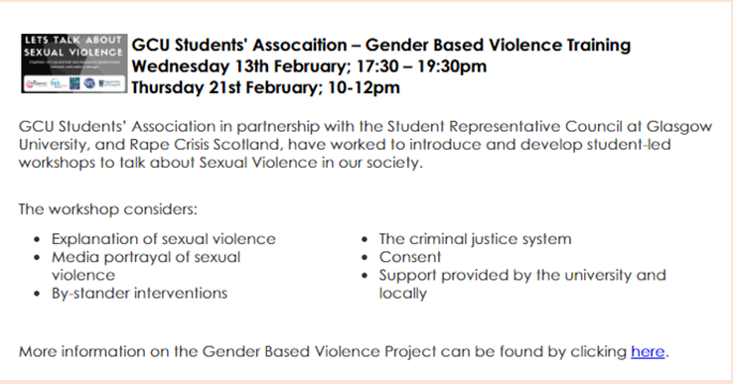
The workshops were delivered as part of the Student Leaders Programme and 3 workshops were delivered throughout the academic year on the following dates:
Trimester 1: 26th October from 2-4pm and 30th October from 17:30 – 19:30pm
Trimester 2: 13th February from 17:30 - 19:30pm

- Continue our Nightline Service
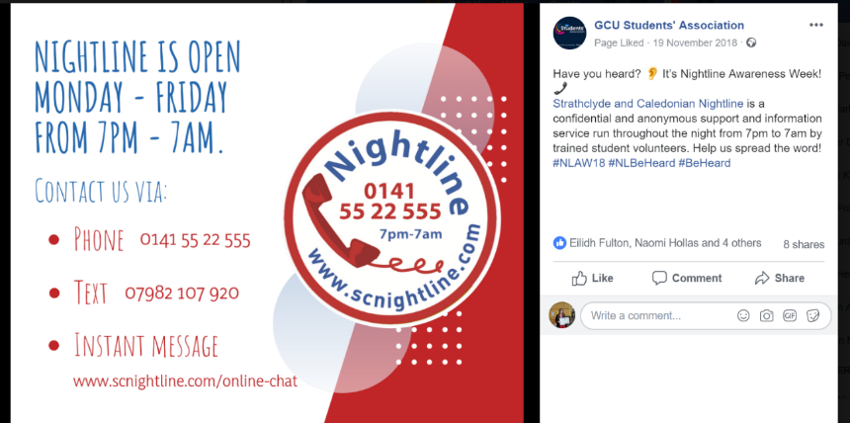
We worked to continue the provision and promotion of our Nightline Service throughout the academic year.

- Postgraduate Space
We worked to open and launch a postgraduate space on campus for the use of our PGT and PGR Students to help establish a community.
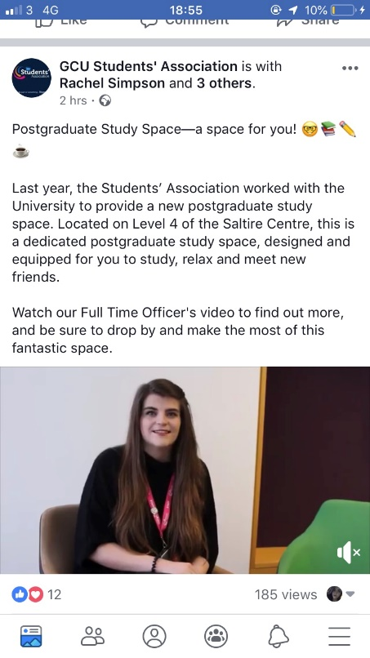
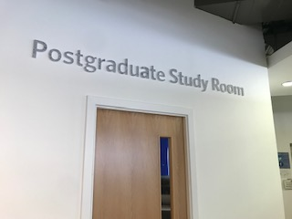
The space opened in the beginning of our Trimester A in September, and was launched to students through a video and online blog by the Full Time Officer Team.

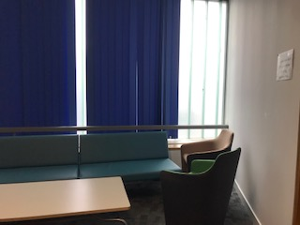

Video and Online Blog here:
https://www.youtube.com/watch?v=9dlDHTbS8A8
https://www.gcustudents.co.uk/articles/postgraduate-study-space

- Establish a quiet space on campus
The GCU Wellbeing Service launched a quiet space on campus within the Faith and Belief Centre during the second trimester 18/19.

- Social meet up groups
The programme occurred every Wednesday afternoon term-time from 2pm until 4pm and included a variety of activities to help boost student’s wellbeing, such as:
wellbeing sessions and workshops, team volunteering, visits to local museums and art galleries, bike rides, yoga, meditation and mindfulness, creative sessions – arts and crafts, music etc., baking and cooking, games, watching films, sports, gardening and photography.

More information can be found here:
www.gcu.ac.uk/student/studentlife/healthandwellbeing/studentwellbeing/workshops/socialmeet-up/
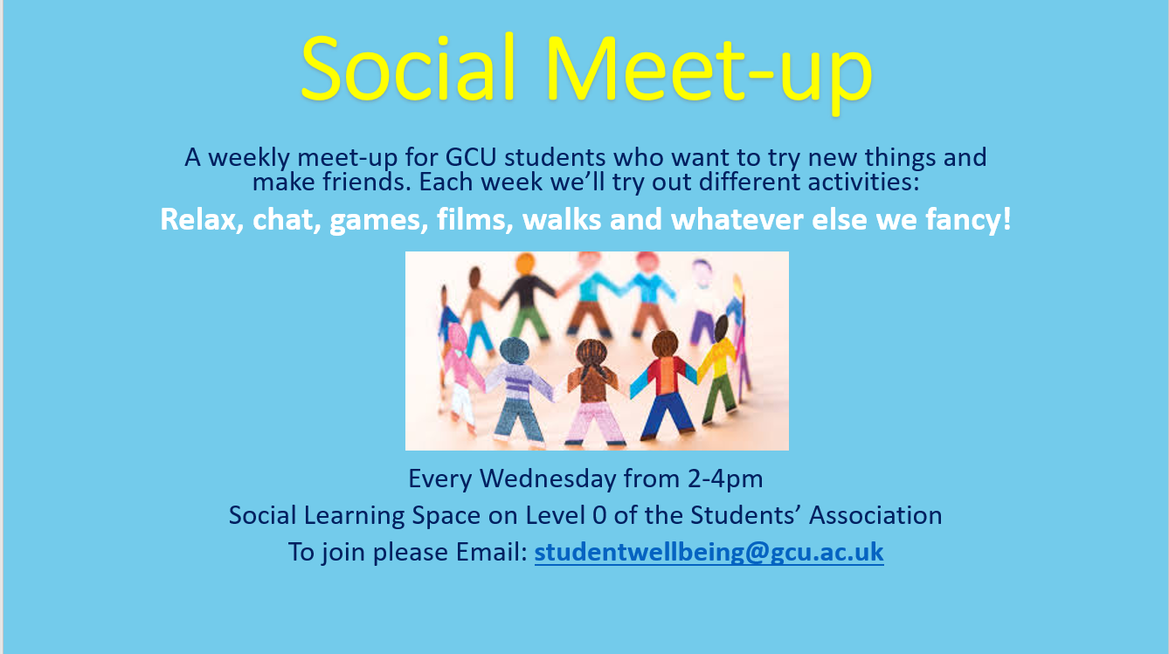

- Free closed yoga groups
The GCU Wellbeing Team continued to work with the on campus gym (the Arc) to provide free closed yoga sessions to GCU Students who were using the wellbeing service provisions, and were identified as being able to benefit from these sessions.

These ran throughout the academic year, and an example communication text from the second trimester has been included below:
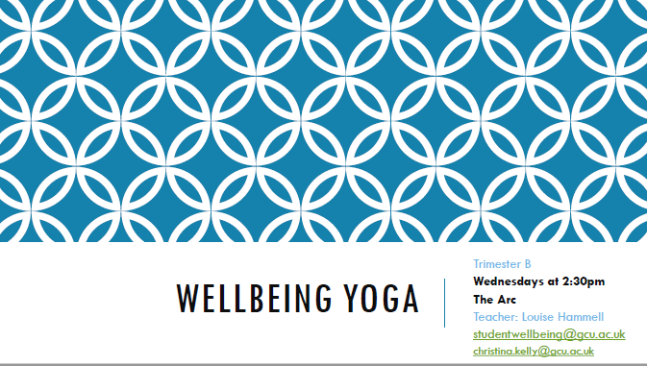

- Action for happiness

Glasgow Caledonian University hosted 'Exploring What Matters', a course created by Action for Happiness throughout the academic year for GCU Students and staff. The courses began on February the 27th and ran for eight weeks from 5.30 to 7.30pm.

Throughout the course participants were able too:
- Meet with like-minded people to explore new ways of looking at things.
- Enjoy expert videos, mindfulness exercises and a handbook full of resources to help them break big ideas into manageable chunks.
- Take time each week to think of small actions they could take to create happiness for themselves and others.

More information about the sessions at Glasgow Caledonian University can be found here:
https://www.eventbrite.co.uk/e/the-action-for-happiness-course-glasgow-27-feb-2019-tickets-54532075907#

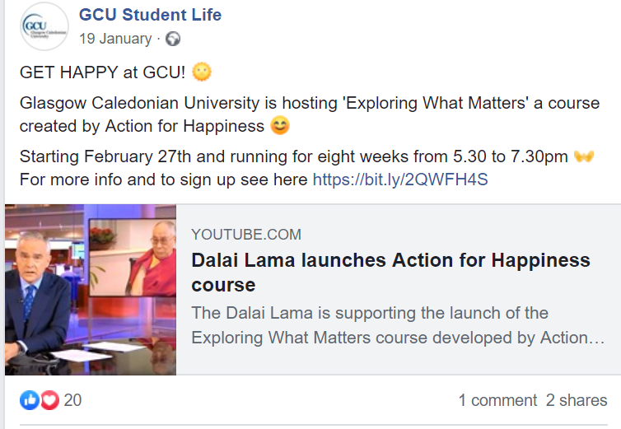
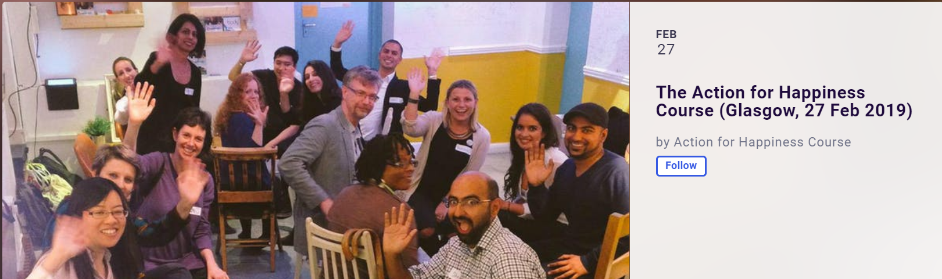

Review policies and report recommendations at GCU
- Undertake a review of the Mitigating Circumstances Policy at GCU

A Mitigating Circumstances working group met annually since the GCU Mitigating Circumstances Policy first became operational in 2012/13. It was identified a full review of the Policy was required in August 2018 and was implemented in time for the start of academic year 2018/19.

Overall the approach was for MITS Boards to adopt a more compassionate approach in their decision making and this shift was clearly identified as required and appropriate. This included the re-introduction of the Personal Tutor role that is able to provide a corroborating statement in support of students’ applications when applicable as well as supporting statements from the GCU Mental Health Adviser.

In addition for those applications which were highlighted as complex mental or physical health challenges, and/or severe and complex life circumstances, such cases were deemed to be exceptional and would require more careful and individual consideration. In those cases a new level of University Mitigating Circumstances Board was introduced to ensure students presenting complex challenges received appropriate support and guidance and to seek supplementary information from their Personal Tutor if appropriate to their case.

We have recently gone through two cycles of the Mitigating Circumstances application process, one in Trimester A and one in Trimester B. It is therefore too early to evaluate and consider the difference this new Policy and process has made for students in the academic year 2018/19 but will be able to evaluate when statistical information has been gathered.

The policy was discussed in a variety of meetings – including the GCU Students’ Association Executive Committee (see below).
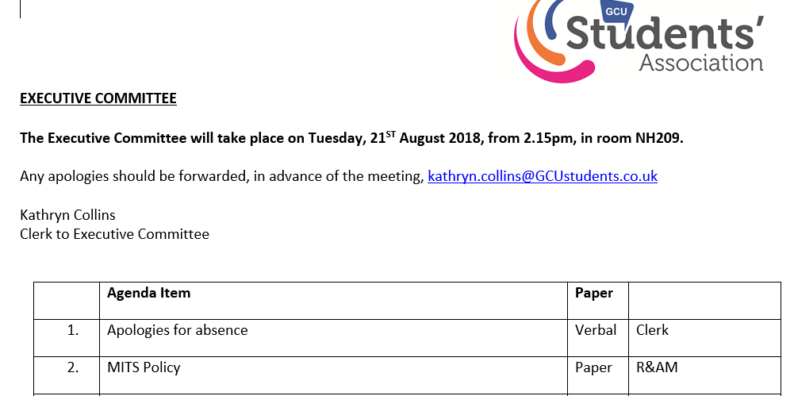

See more info at:
https://www.gcu.ac.uk/student/study/exams/mitigatingcircumstances/

- Revise the role of Academic Advising
Throughout the year, our Academic Quality department in partnership with other departments across the University and the Students’ Association also reviewed our academic advising model. The model has since developed this to become a Personal Tutor, and includes enhancement of the role staff have. One driver for this change was that it was uncovered that students perceived academic advising as purely relating to academic matters, and were not contacting their advisor (now tutor) regarding mitigating circumstances, for support in which department to contact regarding situations, or holistic support.

Moreover, the university student communications department worked to establish a campaign to launch this change to students and staff. The campaign was called #TalkToYourTutor and focused on the role of Personal Tutors, and highlighted individuals and examples of different ways they had support students through their role.
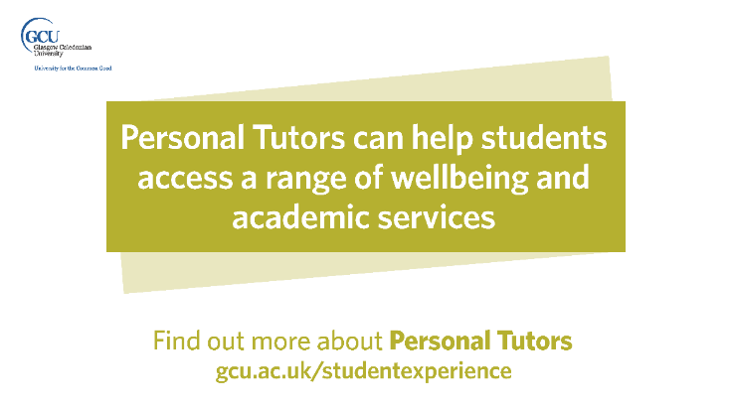
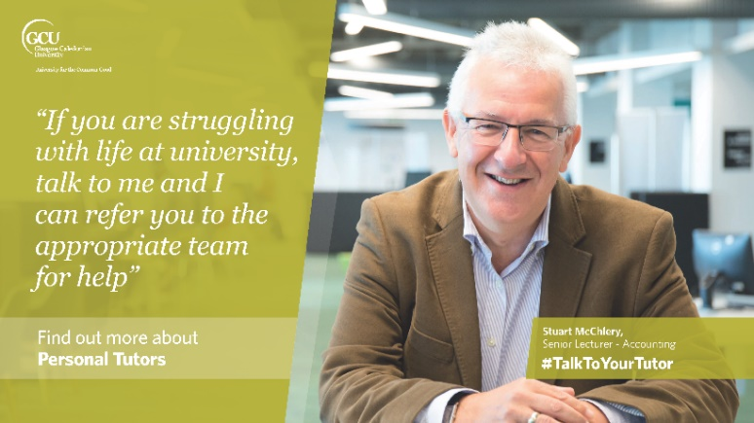
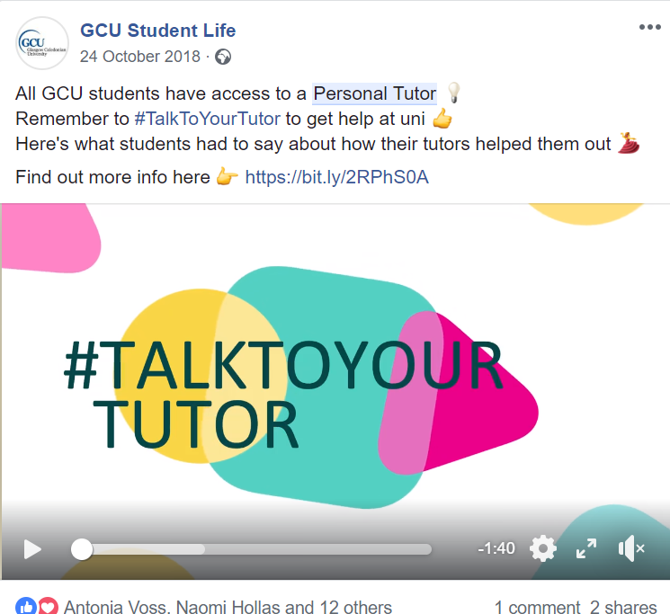

- Enact the report and recommendations from the Student Mental Health Task Group

To ensure the report and recommendations from the Student Mental Health Task Group were carried forward, the University established the Student Wellbeing Action Group (SWAG) in partnership with the GCU Students’ Association. The group also has a remit to oversee the Student Mental Health Action Plan, and Student Mental Health Agreement progress within GCU.

The group has met at various occasions throughout the year, and several actions have been successfully completed.

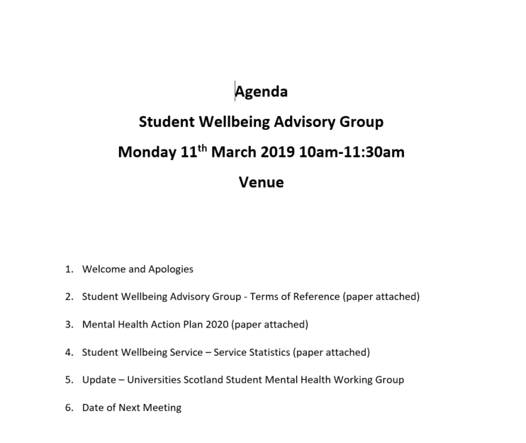

- Further enhance the wellbeing support available to staff

We recognised it was essential to ensure that we were undertaking a holistic approach to wellbeing at GCU, and enhance a community where both staff and students are supported. Since the creation of the SMHA, there have been actions relating to enhancing the wellbeing of staff, however in 18/19 GCU established a specific working group to enhance the mental wellbeing of GCU Staff. The group was known as the Mental Health at Work Taskforce, and produced a report and series of recommendations which have been presented at various committees.

The working group also had representation from GCU Students’ Association from the Student President.

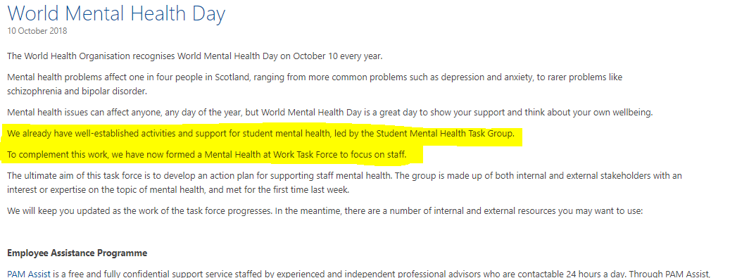

- Mental health and curriculum – INCLUDE Project

To date the project team have:
- Conducted a scoping review of best practice across the HEI sector, globally.
- Carried out a staff consultation event using nominal group consensus development methodology. A nominal group was held with staff from GCU’s Student Wellbeing Service (n=11) including Assistive Technology Advisor; Cognitive Behavioural Therapist; Counsellor; Counsellor; Disability Advisers and Mentors; and Mental Health Advisers. Participants were asked to generate responses to the following question: “What academic or study-related factors do students describe that impact negatively on their mental wellbeing?”

Anticipated further work will include:
- Conducting a review of the records of students who have had an appointment with the Student Wellbeing Service’s Mental Health Adviser to further establish the key curriculum-related reasons that trigger students to seek help from Mental Health services.
- Carry out a further consultation group/workshop with students and staff to develop recommendations for practise.

The project team also met with SPARQs on the 31st of May with the Student President to discuss other ongoing work in the sector in relation to the impacts of curricula design on student wellbeing.

Impact
Provide details of the difference made by focusing on this area. Whenever possible, please back this up with any evidence gathered e.g statistics gathered through surveys, quotes gathered from students and staff etc. Consider the difference this work made to the students, officers, staff and the wider institution.
Delivering and Developing the Student Mental Health Agreement
- Launch Event for the Student Mental Health Agreement
Around 17 tickets were booked for the event, and around 6 Students and 20+ Staff attended the event.
Students and Staff who were able to attend the event found it informative and useful. The event enabled stronger relationships to be developed with some of GCU’s Alumni, and allowed participants to ask questions regarding the Student Mental Health Agreement, and learn more about the work GCU is doing to support its students and staff.
Following the launch of the event, we are working to continue the impact from this, and create new resources and materials for a campaign throughout the next academic year, to increase awareness of the Student Mental Health Agreement. Furthermore, the Safe Taxi Scheme and Support Booklet were launched (and re-launched in the case of the Safe Taxi Scheme) to students and staff, the materials for which will be available beyond the event.

- Student and Staff Mental Health Survey
Feedback gained from the surveys were implemented in various action plans across the University and Students’ Association. Feedback for the staff survey was used in the Mental Health at Work Taskforce and an action plan shaped for the 19/20 Academic Year, and feedback from the student survey was used to begin planning for the 19/20 Student Mental Health Agreement working areas.

Hosting Events on Campus
- World Mental Health Day (10th October)
Raised awareness that it is ok to talk about metal health. Disclosures of mental health conditions are increasing year on year and we see that by promoting mental health awareness we are encouraging students to seek support.

- University Mental Health Day (7th March)
The University wellbeing service in partnership with various departments across the University, Trade Unions and Students’ Association were able to provide a range of activities for GCU Students to enhance their wellbeing. These were well attended, and included free guided bike rides, mindfulness sessions, and more across two days.
Students who attended and participated in the activities provided positive feedback to the University about their experience.

- Wellbeing Fayre

Was attended by 175 students. There were 10 stalls on a range of topics; sexual health, mental health, smoking cessation, oral hygiene, alcohol awareness, personal safety, nutrition and recycling. 15 free massages were given, as well as 35 henna tattoos throughout the course of the fayre.
(Last years stats - needs updated)

- Paws Against Stress Event
The event was well attended and received by students across the campus, and was impactful to their wellbeing as it was scheduled during the beginning of the Trimester B assessment period.

Delivering Campaigns
- Men’s Mental Health
On the 22nd of October 2018, following consultation and discussions with students and staff, the policy establishing a Representation Group and Officer for Men’s Health and Alliance was approved by GCU Students’ Association democratic decision-making body, Student Voice. The remit looks to enhance Men’s health holistically, including their physical and emotional wellbeing, and to identify areas for collaboration with existing campaigns and representation officers.

- Benefits of physical activity on mental wellbeing
The campaign specifically engaged with 281 students over the course of two days. 278 took part in poll on whether university makes it easier or harder to be active, 84 completed cards to give feedback on “How I feel when I Get Active” wall, we provided information to students on various ways to be active on campus using the flowchart and info on stall on various opportunities and also distributed SAMH “5 ways to better Wellbeing” factsheets , HBHM top 10 tips booklets, information on the GCU Cycling projects and Cycling maps of Glasgow, alongside flyer versions of ways to be active on campus flow chart and info sheet.
We also encouraged students to get active through offering free passes to the University Gym to students who purchased a Fresher’s Pack, offering over 30 Come and Try Sports events, with 922 students attending, and engaging with our Universities Cycling Officers to encourage more students to cycle.
Moreover, throughout the Academic Year, GCU and GCU Students’ Associations undertook work for the Healthy Body, Healthy Mind Award for the first time in five years.

- Exam stress
During the exam session for Trimester A, the Advice Centre in the Students’ Association worked to provide a stall for students studying at the 24-hour lab in the Students’ Association. The stall provided students access to support resources, and free fruit. As the stall was unmanned, we were unable to record how many students interacted with the stall.

- Student Mental Health Officer and Representation Group
Following the approval and introduction of the Student Mental Health Officer and Representation Group, there will now be a formal committee within the Students’ Association with centralised the ongoing work on student wellbeing. This enables collaboration across the association, and for efficiencies in the time of effort of key partners in the projects as they can now attend one committee rather than several sub-groups. Moreover, the campaigning work on student wellbeing can continue to be student led through the officer and representation group.

Enhancing and promoting on-campus support services
- Develop a support booklet with every internal support service
Students and staff have fed back that they find the booklet to be an impactful and great idea of the institution. It has helped to centralise all our support and wellbeing provisions into the one place for students and staff to find.

- Host a publicity campaign for the Nightline Service
There was great engagement from students on campus and online, with some statistics outlined below.
- Twitter: 329.4% increase in impressions, 651.4% increase in visits
- Facebook: 200% increase in views, 1042% increase in reach, and 1327% increase in engagements!

- Continuing ongoing advertisement of Advice Centre and Wellbeing Service
GCU Wellbeing Service
By promoting the services we have seen even greater numbers of students that ever access our services. Disability Service users has increase by 11%, Counselling by 4%, and Mental Health Advisers by 14%.

GCU Students’ Association Advice Service
The Advice Service has also seen an increase in the number of students contacting the service for one-off enquiries and casework.

Providing training opportunities for staff and students
- Mental Health Workshop
Over 20 students attended the workshops where they were able to enhance their literacy in mental health and learn more about the impacts of student mental health across the sector, and what support was specifically available to them as GCU Students. Moreover, students were educated on the ongoing work of both the University and the Students’ Association, and given the opportunity to actively shape this work by contributing into a feed-in session with post-it notes.
Student views from the workshops has been typed into a document, and is aimed to be included into the shaping of working criteria for the 19/20 Student Mental Health Agreement.

- Continue the Scottish Mental Health First Aid Award to students
This year, 28 students were able to participate and successfully complete the Scottish Mental Health First Aid Award on the 15th & 22nd of November, and 7th and 14th of Students’ who attended this course gained valuable insight into mental health including the most common mental health problems and how to respond in a mental health crisis situation. Students who completed the course also gained skills appropriate questioning, listening without passing judgement on an individual, giving advice on where to get help. The information and skills gained by students would not have been possible without the course.

Students’ who attended the workshop provided positive feedback in regard to the content alongside feeling they had gained an increased understanding in how to support their peers, as well as learning about various mental health diagnoses. They were also given free booklets and CD’s to take home.
Below are some of the comments left by students in regard to the workshops and the information they learned:
- “A better understanding and more awareness on how to deal with mental health.”
- “In depth understanding of mental health issues, how to address them, risk factors, first aid and good recovery.”
- “I got a better understanding of how to engage with people who are struggling with mental health issues.”
- “I feel very prepared to begin my journey as a mental health first aider.”
- “I learned about different types of mental illness and coping strategies for myself as well as others.”

The feedback further shows how much students enjoyed the course and how valuable they found it in terms of increasing their knowledge surrounding mental health and the skills they gained to be able to respond in a mental health crisis situation.

- Continue to encourage participation n in the SMHFA Course for student facing staff
Staff who attended the training found it very useful and would recommend it. It gave an insight into different MH conditions and how to respond to someone you are concerned about.

- Mindfulness courses
We continued our free mindfulness sessions and 8-week course for GCU students to participate in. The course was fully booked out in Trimester A.

Enhance peer to peer support networks at GCU
- Preventing and Responding to Gender Based Violence Peer to Peer Training
The workshops were scheduled throughout the year and were attended by around 14 students. The students who were trained in how to deliver the workshops found this to be valuable alongside the attendees. Additionally, there were contextualised sessions for our student volunteers, more specifically for our volunteers within the GCU and Strathclyde Nightline Service.

The workshop trainers were recognised at our annual celebration event the Star Awards through the achievement of specific certificates:

Moreover, the structure of the workshops was recognised nationally when Rape Crisis Scotland offered the Student President the opportunity to lead a workshop based on student-led campaigning at a conference in Dublin, Ireland.

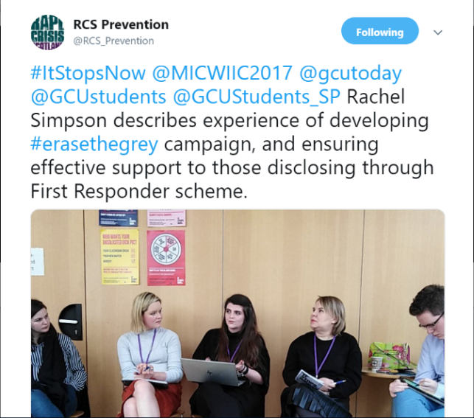
The workshops also compliment other work which has been ongoing at GCU – such as establishing a policy and support booklet for staff and students;
www.gcu.ac.uk/student/studentlife/healthandwellbeing/studentwellbeing/genderbasedviolence/
https://www.gcustudents.co.uk/gbv

- Continue our Nightline Service
The Service has taken over 187 calls (online, text and phone), with the majority received via online messenger. The most frequent call topics were academic stress, stress/anxiety, suicidal thoughts, loneliness, and relationships.

- Postgraduate Space
We opened our new post-graduate space; as research at the campus had indicated a feeling of isolation within our postgraduate students. The study space has been well received within GCU Students and is frequently used, as such there is now a second social space under construction within the School of Computing, Engineering and Built Environment.

- Establish a quiet space on campus
The quiet space was opened in the second trimester for any GCU student to use. The space has been well received from students and staff!

- Social meet up groups
We had a small group attend a number of sessions and enjoyed various activities throughout the year, encouraging students to link in with other university activities, e.g. taster of a society, bike ride, yoga. No formal feedback was gathered, but students have thanked us and have said they enjoyed the group. Some of the students who regularly attended may have otherwise felt anxious about engaging in new groups and activities and we hope this opportunity may have helped them feel less isolated.

- Free closed yoga groups
A small group of students regularly attended the wellbeing yoga sessions and seemed to really enjoy the experience. The social group also attended on two occasions, which was the first time some of them had tried yoga. No formal feedback was gathered.

- Action for happiness
The sessions were well received by GCU Staff and students, with some previous participants referring to the course as “life-changing”.

Review policies and report recommendations at GCU
- Undertake a review of the Mitigating Circumstances Policy at GCU
A new procedure for the submission and review of mitigating circumstances which is more empathetic to the students was launched during the 18/19 academic session. The new procedures, including an updated guidance sheet for GCU students, was produced from a short-life task force which had representation from both GCU and GCU Students’ Association.

The new procedure can be found here:
https://www.gcu.ac.uk/student/study/exams/mitigatingcircumstances/

- Revise the role of Academic Advising
The Academic Advising model has now been reviewed and enhanced with the new Personal Tutor model embedded and communicated to staff and students. The campaign which conveyed the changes was both physical, and through social media. Banners and posters were placed across the GCU Glasgow Campus, and for the online campaign, the video which was produced had over 2,300 views. The combined post reach was over 16,000 and combined post engagements was over 1,200.
The campaign raised students’ awareness of the purpose of a Personal Tutor and feedback received suggested a growth in appointment uptake.

- Enact the report and recommendations from the Student Mental Health Task Group
Several actions from the Student Mental Health Task Force have been completed, with progress being made on other areas of the recommendations. This includes the introduction of a working group for Student Wellbeing known as SWAG, and appointing additional staff within the Student Wellbeing Team.

The additionality of another Mental Health Adviser has ensured that students are getting access to services much quicker. Introducing the Student Wellbeing Advisory group with representation from across the University, Students’ Association and external charities and individuals has ensured that Student Mental Health remains a focus and stays at the top of the agenda.

- Further enhance the wellbeing support available to staff
GCU established the Mental Health at Work Taskforce, which has representation from across the University, Students’ Association, and external partners. The group has produced a report, action plan and recommendations which are being presented to committees across the University, and ways forward being established.

- Mental health and curriculum – INCLUDE Project
Initial project data from the consultation group has indicated that the following top 5 ranked factors impact negatively on students’ mental wellbeing:
- Poorly managed group work [e.g. choosing own group].
- Inappropriate/unsupportive placements - preparation, relationship with mentor.
- Perception of teaching staff attitudes to mental health - e.g. don't care; not feeling respected/listened to.
- Poor quantity and quality of feedback/lack of verbal feedback.
- Lack of social opportunities/social isolation - e.g. peer support; attitudes of peers (discrimination).
The project is still ongoing, but it is anticipated that project outputs would include:
- A set of mental wellbeing curriculum design principles to enhance GCU’s SfL;
- Recommendations for academic staff on embedding mental wellbeing knowledge and skills into their curricula;
A mapping template/ audit checklist of reflective questions that can be used during programme approval/reviews.

Challenges and changes
Provide details of any challenges you faced and any changes you had to make to your plans along the way.
We have highlighted below examples of a few challenges we have faced for some of the working criteria along the academic year:

- Launch Event for the Student Mental Health Agreement
The event occurred during the final week of the second trimester at GCU. This was selected to work with speaker availability, but also at a time where students were more likely to have submitted coursework and class assessments, and therefore have more availability to attend the launch. However, this was found not to be the case, and the student turn out for the event was relatively low. It was identified that the launch should be held earlier in the year in subsequent events.
The event engaged 6 Students, and over 20 members of staff, and it was agreed that following the event in order to expand the impact resources would be established and published online for GCU Students and Staff to utilise.

- Student and Staff Mental Health Survey
Due to the high proportion of surveys which students and staff engage with, it was difficult to help to engage students and staff in filling out the survey process, particularly due to the length of the student survey.

- Men’s Mental Health Campaign
A challenge we faced in undertaking this area of work was the restructuring of the campaign throughout the year due to the change in working criteria from CALM’s campaigns. Although we were unable to arrange a seminar as was first hoped, we felt we were able to embed an impactful structure to ensure sustainable campaigns for men’s health at Glasgow Caledonian University. This challenge, thus, became an asset to our learning and ultimately our delivery of a project to support men’s mental health. It strengthened our resolve to deliver work in this area and refocused the campaign to not only student-led planning but to student-led delivery. Consequently, this not only increased leadership opportunities for our students with the creation of a Men’s Mental Health Officer but the possibility of delivering a series of work over the years and not just a one-off event.

- Continue the Scottish Mental Health First Aid Award to students
The main challenge with running the Scottish Mental Health First Aid training is it is restricted to 16 people per course. This can make it difficult for every student who is interested in taking part to get the chance to do so. We often have a large sign up list with more than 16 people applying to take part in the course. This is run as a first come first serve basis and therefore many students miss out on the opportunity.
The course is also expensive, and as we offer it for free to all students, it is essential that we fill all the spaces. However, due to last minute drop-outs and students failing to turn up on the day spaces can go unfilled.
The course also lasts for 2 full days which for many students is very difficult to commit to due to their timetables at university and for some work out with university. There are very few students who have a completely free day during the week at university with classes alone aside from coursework and other commitments.

- Continue to encourage participation n in the SMHFA Course for student facing staff
The training was scheduled on the same date as poor weather conditions throughout Glasgow which made attending the venue a challenge! However two members of staff were able to attend.

- Mindfulness courses
Due to key members of staff leaving GCU, we are now working to re-establish the sustainability of mindfulness provisions at GCU and GCU Students’ Association.

- Preventing and Responding to Gender Based Violence Peer to Peer Training
The courses are resource intensive to run, both in operational capacity and in finances. Work is ongoing to establish a structure by which to ensure the workshops remain to be sustainable in collaboration with Rape Crisis Scotland.

- Continue our Nightline Service
One of this year’s challenges was the low level of interest in training to become a volunteer in February 2019, with only 6 trainees. With 19 volunteers graduating in summer 2019 this means the service will possibly need to cut back on the number of days it is open in September 2019 before new volunteers can be trained.

- Social meet up groups
The space we booked initially wasn’t ideal as often there were other students working quietly. We moved to a different meeting space in trimester B (bistro), which was more sociable.
Numbers were mostly low and dropped off towards the end of term. We had hoped to continue the weekly group throughout the summer but instead are offering a monthly outing.

Developing the work
Did anything exceed your expectations this year, or was there anything you felt worked particularly well? What would you have done differently if you were to deliver this work in the future?
- Launch Event for the Student Mental Health Agreement
The organisation of the overall event was extremely tailored. Multiple departments across the University and Students’ Association took an active role in ensuring that the event was coordinated and successfully established. The communications for the event were frequent, and there was a huge amount of investment in individual efforts, time, motivation and finances to ensuring the event occurred.

The inclusion of Alumni and external speakers worked to help engage the wider GCU Community in the Student Mental Health Agreement, and the wider role individuals have in ensuring that communities and society are able to be supportive for individuals.

When re-running the launch, we would ensure that the same processes for events planning were used, alongside continuing to engage multiple departments and individuals across both institutions, and external speakers.

- University Mental Health Day (7th March)
We now have contacts for communicating info about wellbeing events for staff
We utilised some of the expertise within the university, e.g. psychology trainees who are required to undertake a certain number of teaching hours and helped deliver workshops – stress management, negative thinking, relaxation techniques
The event benefitted from support of student volunteers and the Psychology Society to help build wider reach on social media. Ideally UMH will become more student led in future (with staff support).

- Men’s Mental Health
We feel that we were able to adapt to the situation to deliver an impactful structure to enhance the wellbeing of students at GCU, and think flexibly about how we could ensure campaigns are delivered at the Association, alongside looking to further reengage our members and ensure that our work continues to be student led.
The officer was established in February 2019, and will be appointed of the Summer period to begin term in Trimester A.

- Develop a support booklet with every internal support service
The development and publication of both physical and online resources for the Student Support Booklet was well received by staff and students. Next steps are to work with a re-fresh of the online digital learning platforms at GCU to establish a support tab for students to access easily alongside other resources such as course material, assessments, library information, etc.

- Continuing ongoing advertisement of Advice Centre and Wellbeing Service
We plan to communicate and plan activities over the summer so that we can spread the word about activities at the start of semester and ongoing throughout the year.

- Mental Health Workshop
The workshop was impactful and informative for the students who were able to attend these. As the workshops were only a part of the Academic Representation Gatherings, we are planning to expand these workshops to be open to any student to attend in the next academic year.

- Continue the Scottish Mental Health First Aid Award to students
The courses were extremely well attended by students. We would look to plan more sessions for GCU students if resources enabled us to do this.

A member of staff from GCU Students’ Association applied to become a SMHFA Instructor in order to enhance the provision of SMHFA workshops available for both staff and students and was unfortunately unsuccessful in this.

- Continue to encourage participation n in the SMHFA Course for student facing staff
In future years we would hope to see this expand to enable more staff at GCU and GCU Students’ Association to undertake the award, and enhance a mentally healthy community at GCU.

- Continue our Nightline Service
Highlights for this year include our participation in the Scotland Regional Conference in November 2018 and the annual Spring Conference in April 2019. Our volunteer delegates found these events to be incredibly inspiring and motivating for them to improve their service in the future.

- Postgraduate Space
The postgraduate space has been well received by students currently, with plans in place to develop a second space on campus for postgraduate students to help build a sense of community and peer support, but also with more of a focus on social communication – as the current space caters more towards a quiet study space.

- Social meet up groups
We hope to widen access to the group by creating an opt-out mailing list that students are referred to via the wellbeing service to find out about our weekly plans and other relevant wellbeing information. It would also be helpful to broaden our reach on social media and ensure regular communication is going out about what we are doing.

Some sessions were more conducive to socialising, e.g. going out for walks, bike ride and cooking. Having this knowledge will help us to develop the group next year.

- Free closed yoga groups
Wellbeing team to be encouraged to invite all students who engage with our services to join our mailing list, which will include info about the weekly yoga sessions. Students to be supported to attend yoga, e.g. by meeting in a group first rather than entering the class alone.

- Mental health and curriculum – INCLUDE Project
The use of the Nominal Group Technique as a consensus development method was excellent for generating ideas and facilitating participants to rank their top priority items.

The project will also produce recommendations to enable staff to design curricula and create teaching and learning environments that are inclusive and promote student mental wellbeing.

Learning for the future
Are there any other working area’s you feel need exploring for next year’s agreement? Consider staff and student feedback.
Most of the points for this area of the evaluation have been address previously in the ‘Developing the work’ or ‘challenges and changes’ section. However, we have expanded on two points specifically below,

- Launch Event for the Student Mental Health Agreement
Going forward, the event should happen annually; but occur halfway through the first trimester in order to engage students with the agreement. This will also enable a further dual purpose as a consultation event for students and staff to feed further into the work and shape the action points of the agreement.

- Social meet up groups
It would be good to build more connections within the university and the community e.g. we had hoped to offer some group volunteering sessions, but the opportunities that came up were not suited to the group we had at the time. This is something we’d like to try and develop.

Any other comments

Throughout the academic year, a number of departments and student groups across the University and Students’ Association undertook work to enhance student and staff wellbeing in addition to the work outlined in the initial Student Mental Health Agreement working areas. We wanted to capture these in the SMHA work and evaluations, so additional areas of work have been captured below.

- GCU Dance Sports Club and GCU Cycling Sports Club raised awareness and funds for SAMH in a cycling challenge
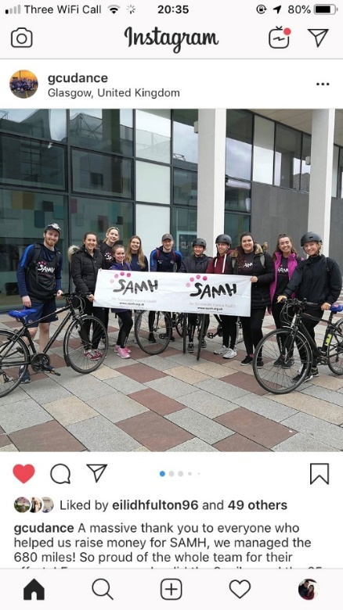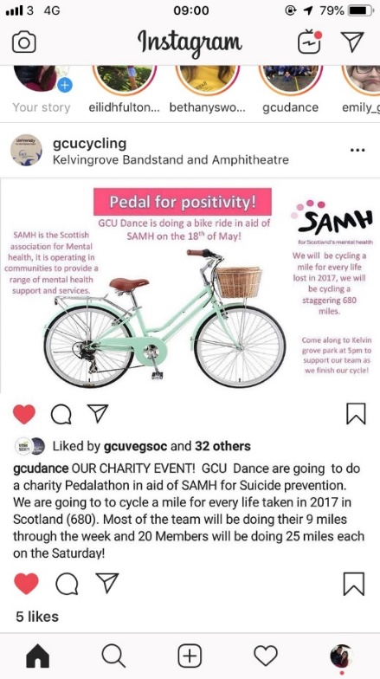
- The GCU Men’s Rugby Team and GCU Women’s’ Rugby Team hosted a Touch Rugby Session for Mental Health (https://www.facebook.com/events/303395147004196/).

- The EDIT – Our Student Magazine, published an article on how to stay mentally well throughout the festive period
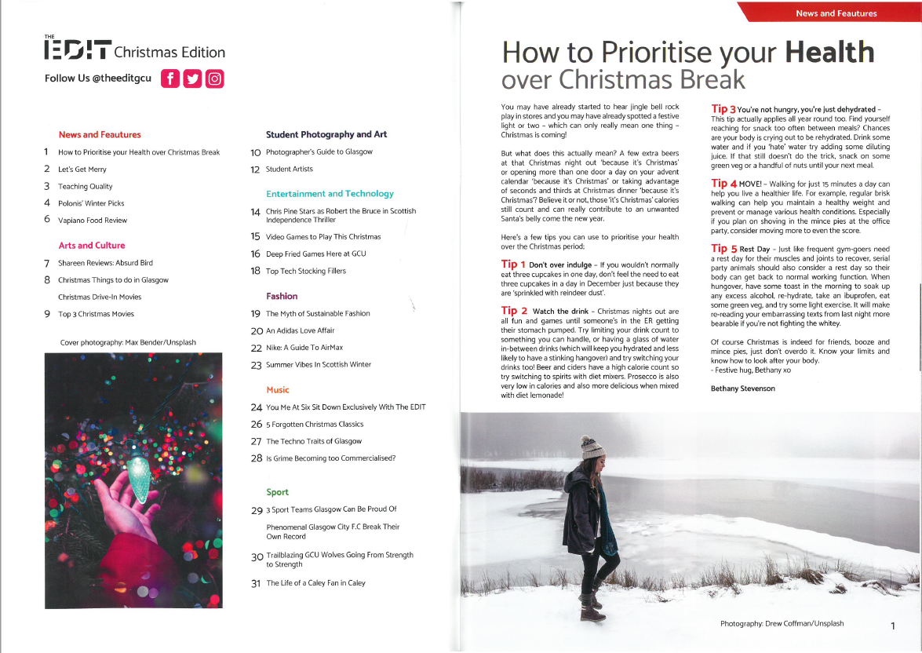

- We opened a roof garden on the first floor of the library to engage students in studying outside and to make use of the green space on campus – which has been linked to increased wellbeing, alongside a hope of promoting an engaging community on campus and increasing social opportunities within students and staff!

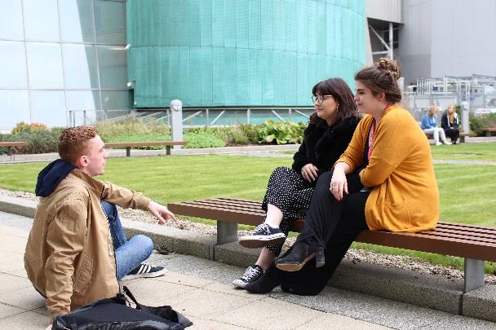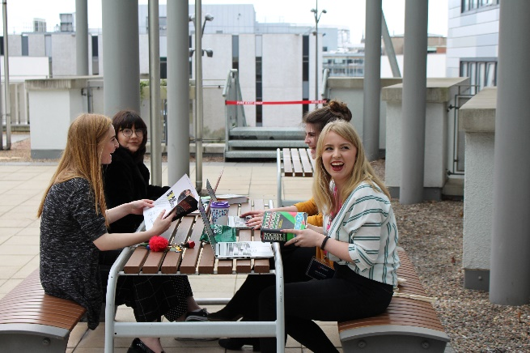
https://www.gcustudents.co.uk/articles/outdoor-learning-spaces-roof-garden-at-the-saltire-centre
Roof Garden Launch Video: https://www.youtube.com/watch?v=6CGKooqqRIg

- In partnership we undertook the Healthy Body, Healthy Mind Award for the first time in 5 years!
