Student Mental Health Agreement:
End of year report 2018
By
Rachel Simpson, Student President GCUSA
Meg MacDonald, Student Advisor GCUSA
Avril Williams, Student Wellbeing Manager GCU

Institution Objectives
Please list the headings on each area of your SMHA. What changes, improvements and/or initiatives did your institution set out to achieve at the beginning of the project and why did you choose these?
Support Services Promotion
Action | Why
Develop a Student Support Booklet | We aimed to produce a booklet which outlined every support service available to GCU students on campus, as well as out of hours contacts, in one easily accessible and understandable place to enable students to seek support.
Nightline Publicity Campaign | We aimed to increase awareness of, and engagement with, the service.
Advertisement of Advice Centre & Wellbeing Service | We aimed to increase awareness of, and engagement with, the services.

Tackling Stigma
Action | Why
Mental Health Campaign | Through events as part of our Wellbeing Volunteering programme we aimed to normalise discussing mental health issues and decrease stigma.
Mental Health Themed Student Summit | We aimed to use feedback from the event to inform the development of a Mental Health action plan to enhance student mental health and well-being at GCU.
Anti-Stigma Speaker on Campus | We aimed to educate students on the topic of mental health stigma, to help tackle this stigma and create a supportive community.
World Mental Health Day (10th October) | We aimed to raise awareness of mental health issues and mobilize efforts in support of better mental health.
University Mental Health Day (1st March) | We aimed to raise awareness of mental health issues and mobilize efforts in support of better mental health.
SMHFA Course – Staff | We aimed to empower staff to support students’ mental health needs.

Peer Support Networks
Action | Why
SMHFA – Students | We aimed to empower students to support students’ mental health.
Preventing and Responding to Gender Based Violence Peer to Peer (Lets Talk) Training | We aimed to create a supportive community for those impacted by gender-based violence, alongside tackling societal issues through education.
Nightline Service | We committed to continuing the Nightline Service through devoting staff time and funding for training volunteers and supporting the service. This service supports students when other university services are unavailable (Monday-Friday 7pm-7am).
Promote Gender and Sexuality Safe Space | Raise awareness of the Safe Space to encourage student usage of space for peer support.
Introduce mindfulness course | Aimed to equip students with skills to assist in their mental wellbeing.
Introduce 6 Week My RAP Workshop | Aimed to equip students with skills to assist in their mental wellbeing.
Look After Your Mate Workshops | Aimed to equip students with skills to assist in their mental wellbeing.

What you expected to do
Set out how you expected to take forward your institutional objective, providing brief details of these plans and how you intended to progress them.
Before work on our proposed topic areas began; action plans were constructed and can be seen in the Student Mental Health Agreement, which has been included as Appendix 1. To fully answer the above, we have also summarised below each objective, and how we aimed to achieve them.
Support Services Promotion
Develop a Support Booklet
We expected to develop a support booklet which would bring together every GCU and GCU Students’ Association support service into one booklet, as well as out of hours contacts for students. The idea for this was that this information didn’t exist in one place for students to easily access prior to the booklet, and lead to the possibility that students may not be aware of all the support services provided at GCU.

Nightline Publicity Campaign
A campaign to take place during the Nightline Awareness week and other campaigns throughout the year.

- Advertisement of Advice Centre and Wellbeing Service
The intention was to include the services and events they may run in various methods of promotion. This included bi-weekly all student email, tweets and Facebook posts about the services, and advertising through Wellbeing Campaigns and the Annual Wellbeing Fayre.

Tackling Stigma
Mental Health Campaign (Wellbeing Volunteering)
We expected to have a two-day campaign to engage students in a discussion around mental health and stigma to raise awareness around mental health issues and tackle problems of stigma and isolation. We also expected to feature mental health information at the Wellbeing Fayre in March, including representatives from the University Counselling Centre and Breathing Space.

Mental Health Student Summit
Each year GCU host an event called the Student Summit in which students and staff come together to provide feedback on key issues or policies. This year, we aimed to centre the summit around the topic of Student Wellbeing, and gain feedback both for this agreement, and the University’s Mental Health Action Plan.

Anti-Stigma Speaker on Campus
We hoped to bring a speaker onto campus who would be able to educate students on the topic of mental health stigma, the impacts of this, and how they could challenge it in their everyday lives.

World Mental Health Day
We intended to host a series of events and activities to raise awareness of mental health issues and mobilize effort to support better mental health.

University Mental Health Day
We intended to host a series of events and activities to raise awareness of mental health issues and mobilize effort to support better mental health.

Encourage Participants in SMHFA Course for Student Facing Staff
We intended to encourage student facing staff to partake in the Scottish Mental Health First Aid Course. This was to encourage even more of a supportive community on campus at GCU from staff and students (see below in Peer Support Networks).

Peer Support Networks
Introduce the SMHFA to Students
We wanted to equip students with the skills to help create a holistic and supportive community at GCU; alongside enabling a higher awareness of mental health, the stigmas around it, and how they can support greater mental health in both themselves and their peers.

Let’s Talk about GBV Workshops
The Let’s Talk about Gender Based Violence Workshops are developed in partnership with Rape Crisis Scotland and Glasgow University’s SRC to help challenge and prevent gender-based violence in society. The workshops provide trainers and attendees with a list of support services for those impacted by this; for example, Rape Crisis, and the Archway. The aim of the workshops were to provide an increased awareness of gender based violence within the GCU student community.

Continue our Nightline Service
We expected to recruit a minimum of 30 volunteers to deliver the free, confidential listening and information service, Monday-Friday 7pm-7am Monday-Friday during term times.

Promote the Gender and Sexuality Safe Space
We wanted to increase awareness and knowledge of the space and encourage more students to make use of the supportive environment.

Introduce a 8 Week Mindfulness Based Stress Reduction Courses
We aimed to equip students with skills to assist in their mental wellbeing through a structured course which would be provided by the University Wellbeing team.

Introduce a 6 Week My Recovery Action Plan (My Rap) Workshop
We aimed to equip students with skills to assist in their mental wellbeing through a structured course which would be provided by the University Wellbeing team.

Introduce Look After Your Mate Workshops
We aimed to equip students with skills to assist in their mental wellbeing through a structured course which would be provided by the University Wellbeing team.

What you actually did
Provide a brief summary of activity across the year, including key dates and events and links to any relevant information.
Support Services Promotion
Develop a Support Booklet
During September – December various departments across the university were contacted and asked if they would like to be included in a support booklet for GCU. The booklet aimed to outline every University and Association support service in one easily understandable place for students, alongside out of hours support contacts.

The booklet is presently being finalised after alterations were required due to a re-launch of the Safe Taxis Scheme; and will be launched for GCU Students at the September freshers’ fayre.

Nightline Publicity Campaign
On November 23rd as part of the Nightline Awareness week, Nightline held a “Paws Against Stress” event in partnership with Canine Concern Scotland. Over the course of 2 hours, almost 100 students interacted with a friendly Therapet and their owner. During the event, Nightline flyers and key rings were handed out to each attendee. Photos of the day were shared on the Nightline and GCU Students’ Association Facebook pages. Also in November, volunteers put up 50 Nightline information posters around campus.

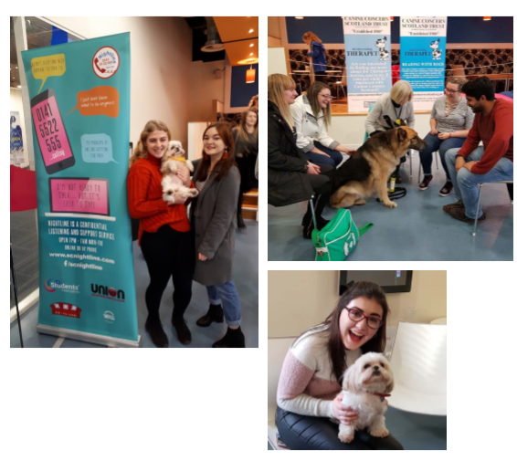

On 3rd April, Nightline volunteers set up tables with free bottled water as well as Nightline resources to help increase wellbeing and awareness of the service to students. The event was called “Don’t bottle it up”.

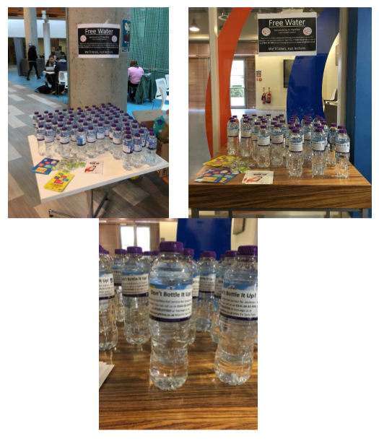

Advertisement of Advice Centre and Wellbeing Service
We sent out bi-weekly all student emails, tweets and Facebook posts about the Advice Centre services. We advertised the Advice Centre and Wellbeing Service through Wellbeing Campaigns at GCU Students’ Association through providing leaflets with contact information in each of the 6 Wellbeing Campaigns.

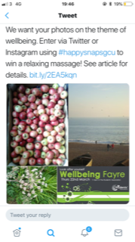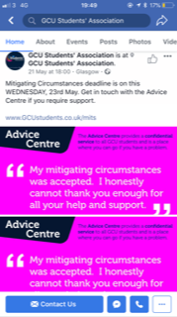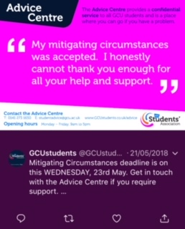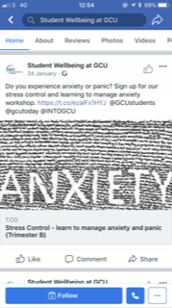

Tackling Stigma
Mental Health Campaign (Wellbeing Volunteering)
The Mental Health Stigma campaign took place 28th & 30th November in partnership with SeeMe Scotland.

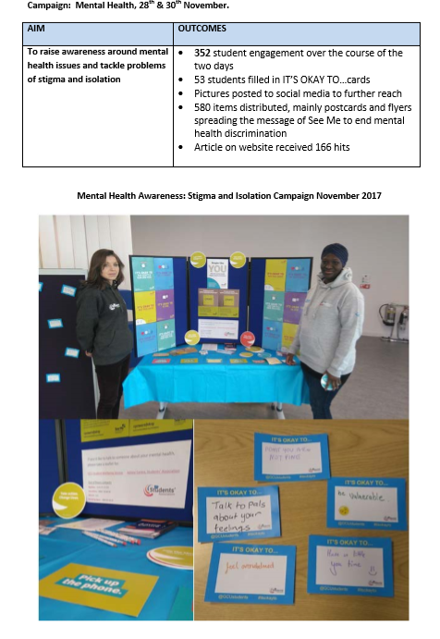

We also hosted a Wellbeing Fayre on March the 22nd. This featured mental health information, as well as relaxation activities such as massages and henna.

https://www.facebook.com/events/101866373961697/

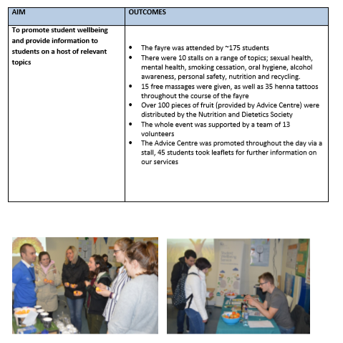

Mental Health Student Summit
Each year, GCU Students’ Association and GCU host a Student Summit on topics which impact upon student and staff experiences; and invite individuals along to help shape policies and ideas. This year the summit was on the topic of “Mental Wealth – Enhancing GCU Student Wellbeing” and was held on Monday the 26th of February.
https://www.facebook.com/events/169343983698179/

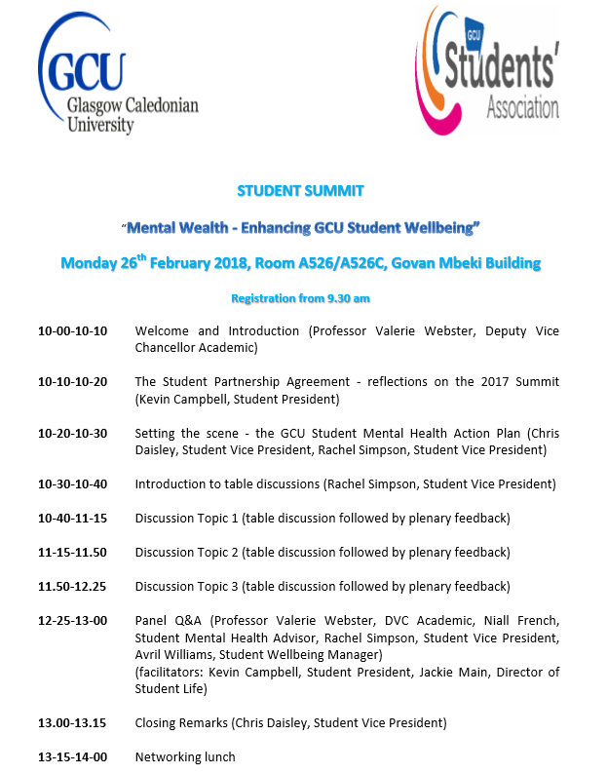

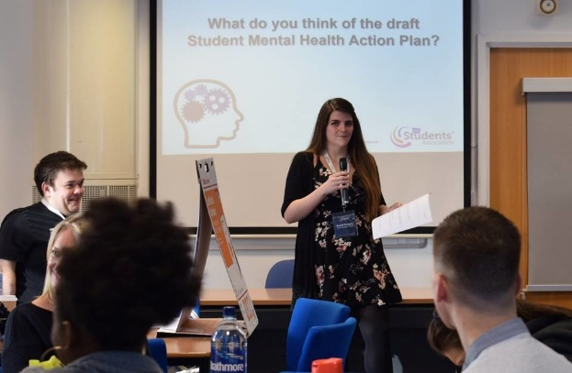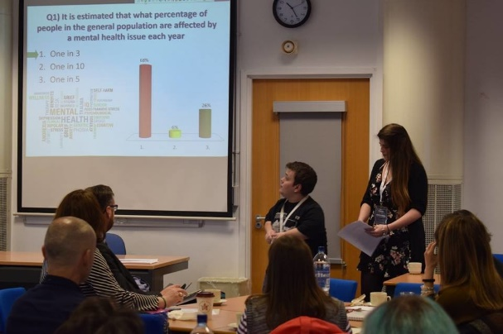

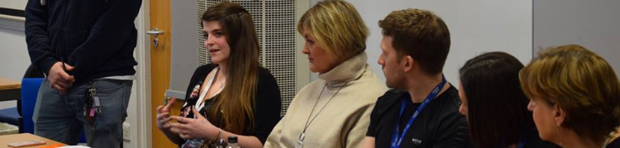

Anti-Stigma Speaker on Campus
We aimed to have an anti-stigma speaker come onto our Glasgow campus and deliver a lecture to individuals on the impacts of mental health stigma, and how students could combat this. Although we had a speaker from SeeMe deliver a small talk to our Wellbeing Volunteers prior to the Campaign in November; a larger talk was unfortunately unable to be organised for the academic year 17/18.

World Mental Health Day
This was on the 10th October 2017 and was promoted through social media.

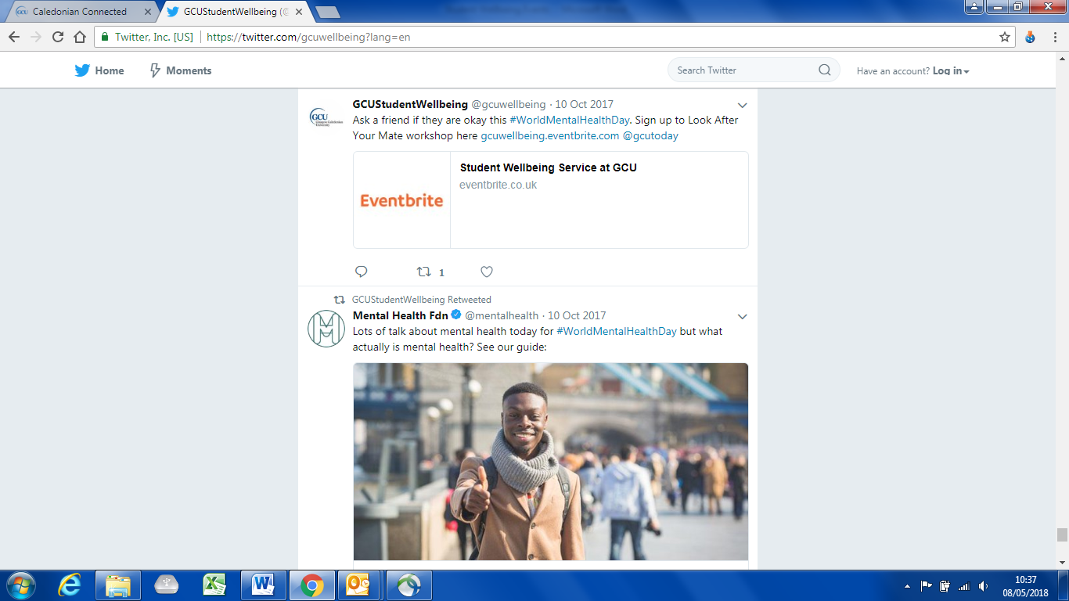

University Mental Health Day
University Mental Health Day this year was on the 1st of March 2018. The theme this year was 'community' so on campus we had arranged for Lindsey and Roger from local community enterprise, The Space to come and talk about what they do and give free items to students, and Garry from 'Mind and Draw' offering taster sessions of his wonderful art workshops.
https://www.facebook.com/events/530335037349801/

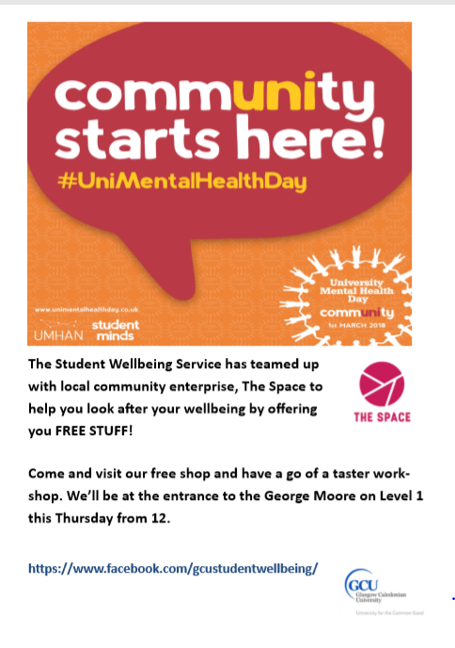

Encourage Participants in SMHFA Course for Student Facing Staff
A Disability Adviser and a Disability Mentor attended the training on 30th and 31st January 2018.

Peer Support Networks
Introduce the SMHFA to Students
During September 2017, GCU Students’ Association included the Scottish Mental Health First Aid Award to GCU Students’ through our Student Leaders Programme. The session was free for GCU students to attend; and well-advertised as both sessions were fully booked.

www.gcustudents.co.uk/articles/mental-health-first-aid-training-feef

Let’s Talk about GBV Workshops
Both institutions in partnership with Glasgow University and Rape Crisis Scotland trained a group of GCU students on the 29th of August until the 1st of September 2017 to deliver “Let’s Talk” Workshops throughout the academic year. The workshops were delivered by GCU Students, to GCU Students in order to create a supportive community at GCU in preventing and responding to Gender Based Violence.

www.gcustudents.co.uk/articles/preventing-and-responding-to-gender-based-violence

The workshops were delivered independently, alongside being embedded into GCU Students’ Associations’ Student Leaders Programme.

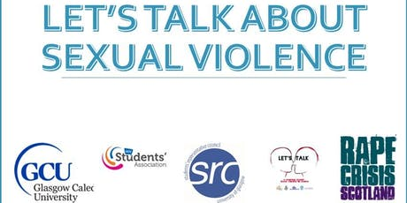

https://www.eventbrite.co.uk/e/lets-talk-about-sexual-violence-tickets-38729657448?utm-medium=discovery&utm-campaign=social&utm-content=attendeeshare&aff=escb&utm-source=cp&utm-term=eventcard

The workshops also compliment other work which has been ongoing at GCU – such as establishing a policy and support booklet for staff and students;

www.gcu.ac.uk/student/studentlife/healthandwellbeing/studentwellbeing/genderbasedviolence/

Continue our Nightline Service
We recruited a total of 42 volunteers who delivered the free, confidential listening and information service, Monday-Friday 7pm-7am Monday-Friday during term times.

www.gcustudents.co.uk/groups/nightline-volunteer

www.scnightline.com

Promote the Gender and Sexuality Safe Space
GCU Students’ Association published a blog on the Safe Space on level 2 of the Association. The blog was shared multiple times across social media platforms to try and engage students and increase awareness of the space. The Safe Space will also feature in the support booklet.
www.gcustudents.co.uk/articles/gender-and-sexuality-safe-space

Introduce a 8 Week Mindfulness Based Stress Reduction Courses
This was facilitated by the Counselling Team who held a taster session for the course on 10th October 2017. 35 people signed up for this. After the session around 10-15 people signed up for and regularly attended the 8 week course.

https://www.eventbrite.co.uk/e/mindfulness-for-students-taster-session-tickets-38003416241?utm-medium=discovery&utm-campaign=social&utm-content=attendeeshare&aff=escb&utm-source=cp&utm-term=eventcard

Introduce a 6 Week My Recovery Action Plan (My Rap) Workshop
This was facilitated by our Mental Health Adviser, who is a registered Mental Health Nurse. It ran for 6 weeks from 24th October 2017 and 6 people attended the group for all sessions.
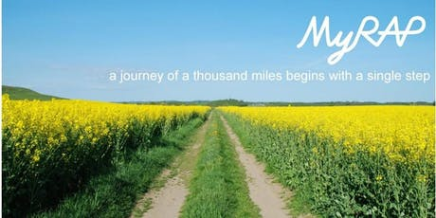
https://www.eventbrite.co.uk/e/my-recovery-action-plan-group-workshops-tickets-37686543466?utm-medium=discovery&utm-campaign=social&utm-content=attendeeshare&aff=escb&utm-source=cp&utm-term=eventcard

Introduce Look After Your Mate Workshops
This ran on 8th November 2017 and was facilitated by our Student Wellbeing Adviser with 7 attendees.

https://www.eventbrite.co.uk/e/look-after-your-mate-2017-tickets-37600181154?utm-medium=discovery&utm-campaign=social&utm-content=attendeeshare&aff=escb&utm-source=cp&utm-term=eventcard

What difference you made
Provide details of the difference made by your work – where possible, please back this up with any evidence gathered (e.g statistics gathered through surveys, quotes gathered from students taking part in your project). Consider the difference this work made to the students, officers, staff and the institution.
Support Services Promotion
Develop a Support Booklet
The booklet is still to be completed and distributed to students – however there were students engaged in the design process when selecting services to be included in the booklet; and a majority of students reported that they had been unaware of the wide selection of support services available.

Nightline Publicity Campaign
“Paws Against Stress” event, over the course of 2 hours, almost 100 students interacted with a friendly Therapet and their owner. During the event, Nightline flyers and key rings were handed out to each attendee. Photos of the day were shared on the Nightline and GCU Students’ Association Facebook pages. We hope to have increased the awareness of the service and provided a positive outlet for stress for students.

In November 50 Nightline information posters were put up around campus.

On 3rd April, 120 water bottles with Nightline contact information, along with other resources were distributed. We hope to have increased the awareness of the service and provided a healthy drink to students.

Advertisement of Advice Centre and Wellbeing Service
Over 500 Advice Centre postcards/leaflets were distributed throughout the 6 campaigns. Regular communications went out to students via all student email and social media.

Tackling Stigma
Mental Health Campaign (Wellbeing Volunteering)
The Mental Health Stigma campaign:
352 students were engaged over the course of the two days, 53 students filled in IT’S OKAY TO…cards, Pictures which were then posted to social media to further their reach, 580 items distributed, mainly postcards and flyers spreading the message of See Me to end mental health discrimination, article on website received 166 hits.

The Wellbeing Fayre:
Was attended by 175 students. There were 10 stalls on a range of topics; sexual health, mental health, smoking cessation, oral hygiene, alcohol awareness, personal safety, nutrition and recycling. 15 free massages were given, as well as 35 henna tattoos throughout the course of the fayre.

Mental Health Student Summit
Students and Staff attended the Mental Health Summit on the 26th of February. The feedback provided at the summit was collated into a report; which was then used to help shape both the Universities Mental Health Action Plan, alongside plans for the 18/19 Student Mental Health Agreement, and used to evaluate work sections chosen for this year’s agreement.

Anti-Stigma Speaker on Campus
Ongoing, with plans on track for this to occur in Trimester A 2018/19.

World Mental Health Day
Raised awareness that it is ok to talk about metal health. Disclosures of mental health conditions are increasing year on year and we see that by promoting mental health awareness we are encouraging students to seek support.

University Mental Health Day
Unfortunately events were cancelled as the University was closed due to severe weather.

Encourage Participants in SMHFA Course for Student Facing Staff
The staff found this training very useful and would recommend it. It gave an insight into different MH conditions and also how to respond to someone you are concerned about. The resources they were given to take away have made their way around the office.

Peer Support Networks
Introduce the SMHFA to Students
Students’ who attended the workshop provided positive feedback in regard to the content alongside feeling they had gained an increased understanding in how to support their peers, as well as learning about various mental health diagnoses. They were also given free booklets to take home.

Let’s Talk about GBV Workshops
The workshops were scheduled throughout the year and were attended by around 20 students. The students who were trained in how to deliver the workshops found this to be valuable alongside the attendees.

Continue our Nightline Service
The Service has taken over 260 calls (online, text and phone). Loneliness, Suicidal Thoughts and Academic Stress/Depression were the top 3 trends this year, which highlights the serious issues that the volunteers are supporting their fellow student callers with through the night.

Promote the Gender and Sexuality Safe Space
The space has been promoted through a blog, and we have seen an increased usage, alongside general awareness from students about the space since. As a result, student groups have also introduced more self-help resources to the space also, alongside condoms and sanitary products.

Introduce a 8 Week Mindfulness Based Stress Reduction Courses
An online survey was completed by participants. Feedback included ‘positive impact on my ability to manage demands’, ‘I am less judgmental about myself’ and ‘it gave me the necessary tools to deal with stress’.

Introduce a 6 Week My Recovery Action Plan (My Rap) Workshop
Attendees welcomed the peer support element of the workshop and friendships were formed amongst those attending.

Introduce Look After Your Mate Workshops
Feedback from attendees was positive and they felt that this also equipped them to look after their own mental health as well as that of others.

