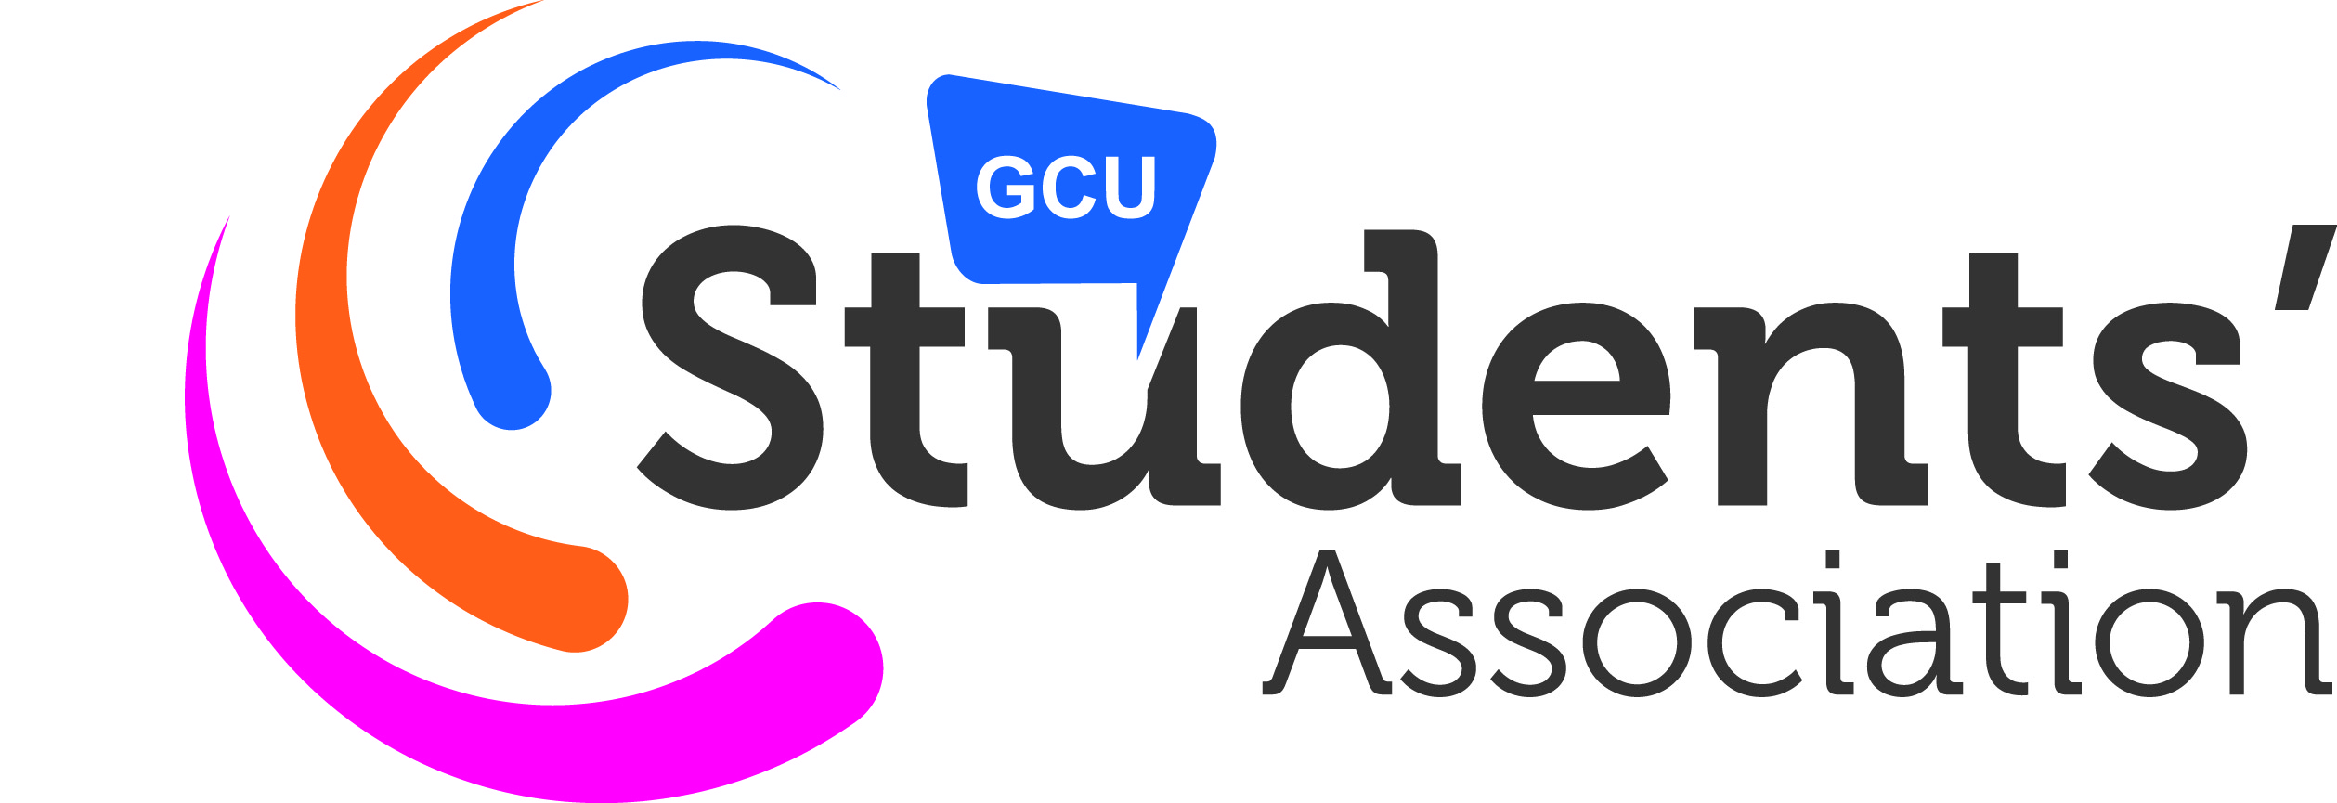
Event or Activity Risk Assessment

A risk assessment is not about creating huge amounts of paperwork, it is about identifying sensible measures to control the risks at your event or activity. You are probably already taking steps to protect participants, but this risk assessment will help you decide whether you have covered all you need to. Follow the guide in the blue table and review this Risk Assessment by thinking about how accidents and ill health could happen and how you will prevent or reduce the likelihood of it occurring. More information on risk rating is provided below.

EVENT OR ACTIVITY | BAKE SALE | FORM COMPLETED BY
DATE OF EVENT or ACTIVITY |  | EMAIL ADDRESS
LOCATION OF EVENT or ACTIVITY |  | DATE FORM COMPLETED

Likelihood \ Harm | Slightly Harmful (SH) | Harmful (H) | Extremely Harmful (EH)
Highly Unlikely (H UNL) | TRIVIAL RISK (TR) | TOLERABLE RISK (T) | MODERATE RISK (M)
Unlikely (UNL) | TOLERABLE RISK (T) | MODERATE RISK (M) | SUBSTANTIAL RISK (S)
Likely (L) | MODERATE RISK (M) | SUBSTANTIAL RISK (S) | INTOLERABLE RISK (IN)
Risk Rating Chart

List all the different types of activities that are being assessed. | For each activity list the hazards, i.e. anything that has the potential to cause harm. | For each hazard list the potential injuries. | For each hazard list the persons at risk. | For each hazard list the measure to be used to reduce or prevent the hazard from causing injury. | Use the chart to provide a rating for each hazard with protective and preventative measures in place. Further action will be required for any risk rating in red. | Is their any further action required?

Activity | Hazard | Potential Injury | Persons  at Risk | Preventative and Protective Measures | Likeli  hood | Harm | Risk Rating | Further Action
Baking | Hot ovens and kitchen wear | Burns | Individuals baking. | Individual with valid food hygiene certificate overseeing all baking and advising on good practice.  Taking care using oven/stove and ensuring appropriate oven gloves are used. | HUNL | H | T
Baking | Contamination | Food poisoning | Individuals consuming the home baking baking. | Individual with valid food hygiene certificate overseeing all baking and advising on good practice.  Copy of certificate must be provided to Students’ Association in advance of baking. | UNL | SH | T
Sale of home baking | Contamination | Food poisoning | Individuals consuming the home baking baking. | Individual with valid food hygiene certificate overseeing all transportation and storing of home baking and advising on good practice.  Food handler should use tongs or wear appropriate gloves.  No home baking that requires refrigeration e.g. fresh cream cakes.  Appropriate storage containers used for all home baking. | UNL | SH | T
Sale of home baking | Selling to individuals with allergies. | Allergic reaction dependant on individual and severity of allergy. | Individuals with allergies consuming home baking. | Signage advising that items are home baked and may contain allergy sensitive ingredients.  Signage available from Students’ Association. | HUNL | H | T
Sale of home baking | Attack/theft of money. | Assault injuries. | Individuals selling cakes. | Ensure that money is kept out of view (preferably in a locked box) and regularly emptied with contents taken to Students’ Association to be put in the safe.  Ensure there is a minimum of 2 individuals on the stall at all times.  All volunteers on stall should be advised that should this occur, no attempt to intervene should be made and raise the alarm immediately. | HUNL | H | T

The student with a food hygiene certificate is [add name here] and the certificate will be brought into the Students’ Association or scanned and emailed in.

Food Hygiene Certificate – Online Courses:

www.food-hygiene-certificate.co.uk

www.virtual-college.co.uk/products/food-hygiene-catering.aspx

Risk Rating Scale

 | Slightly Harmful (SH) | Harmful (H) | Extremely Harmful (EH)
Highly Unlikely (H UNL) | TRIVIAL RISK | TOLERABLE RISK | MODERATE RISK
Unlikely (UNL) | TOLERABLE RISK | MODERATE RISK | SUBSTANTIAL RISK
Likely (L) | MODERATE RISK | SUBSTANTIAL RISK | INTOLERABLE RISK

RISK LEVEL | ACTION AND TIMESCALE
TRIVIAL (TR) | No action is required and no documentary records need to be kept.
TOLERABLE (T) | No additional controls are required. Consideration may be given to a more cost-effective solution or improvement that imposes no additional cost burden. Monitoring is required to ensure that controls are maintained.
MODERATE (M) | Efforts should be made to reduce the risk, but the costs of prevention should be carefully measured and limited. Risk reduction measures should be implemented within a defined time period.  Where the moderate risk is associated with extremely harmful consequences, further assessment may be necessary to establish precisely the likelihood of harm as a basis for determining the need for improved control measures.
SUBSTANTIAL (S) | Activity should not be started until the risk has been reduced. Considerable resources may have to be allocated to reduce the risk. Where the risk involves activity in progress, urgent action should be taken.
INTOLERABLE (INT) | Activity should not be started or continued until the risk has been reduced. If it is not possible to reduce risk even with unlimited resources, activity has to remain prohibited.

Note: In this context Tolerable means that the risk has been reduced to the lowest level that is reasonably practicable.

Factors to Consider Whilst Determining the Risk

Risk depends on the severity of the harm and the likelihood of harm. In deciding on the severity of harm you have to consider the nature of the harm.

Is it slightly harmful? e.g Superficial injuries: eye irritation from dust, Nuisance and irritation (e.g. Headaches); ill-health leading to temporary discomfort

Is it harmful? e.g. Lacerations; burns; concussion; serious sprains; minor fractures; Deafness; dermatitis; asthma; work related upper limb disorders; ill-health leading to permanent minor disability

Is it extremely harmful? e.g. Amputations; major fractures; poisonings; multiple injuries; fatal injuries, occupational
cancer; other severely life shortening diseases; acute fatal diseases

In deciding on the likelihood of harm the adequacy of control measures already implemented and complied with needs to be considered. You would then typically consider the following issues in addition to the activity information, which you uncovered earlier.

- Number of persons exposed
- Frequency and duration of exposure to the hazard
- Failure of services e.g. Electricity and water
- Failure of safety devices
- Exposure to the elements
- Protection afforded by personal protective equipment and usage rate of personal protective equipment
- Unsafe acts (unintended errors or intentional violations of procedures) by persons, for example, who may not know what the hazards are, may not have the knowledge, physical capacity, or skills to do the activity. Or underestimate risks to which they are exposed. Underestimate the practicality and utility of safe working methods.

