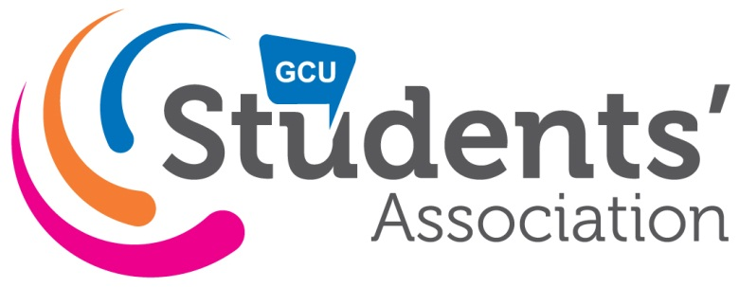
Radio Caley Minutes

Date: 05-12-17
Time: 5pm-6.15pm
Room: NH208

 | Agenda item | Action | Person responsible
 | Welcome |  | Chair
 | In Attendance  Station Manager, Tom Jarvis;  Head of IT, Callum Smith;  Head of Events, Lauren Mair;  Head of Music, Philippa Fraser;  Head of Audio Technology, Alex Rycroft;  Head of Fundraising, Jack Anderson;  Head of Multimedia, Amy Byrne;  VP SHLS, Yetunde Ogedengbe.  Josie McKay, Communications and Media Co-ordinator – Clerk. |  | Chair
 | Apologies  Head of Presenters, Madeleine Jane Dunne. |  | Clerk
 | Approval of Previous Minutes  Chair didn’t talk about previous minutes |  | Chair
 | Matters Arising  - Head of Audio Tech Position  Alex Rycroft is leaving his position at the end of 2017 as he is moving country therefore Head of Audio position will need to go a by-election. Manager has heard of interested members. The committee talked generally about the by-election and decided the deadline for manifestos is midnight Sunday 10th December 2017.  Hustings and vote will take place at 5pm on Wed 13th December before Saasmass event.  Handover will happen before Alex has left the country.  - Saasmass  The committee had challenges with the Re:union bar so have had to make the event free. As this was going to be a fundraiser event the committee have decided to have competition and raffles on the night with prizes. There was general chat about how they could win the prizes. The committee will post ideas on the volunteers page and get them to vote.  - Getaway  25 tickets have been sold in less then 24 hours. As Callum had trouble with the SA website system he used Eventbrite which resulted in a fee per ticket. The tickets were sold for £35 each with £32 from each ticket being released for the event. The event organisers can release more tickets but having to work out logistics first. There are 5 people on the waiting list at the moment.  Any drivers get to go for free. The committee recognise that drivers need adequate sleep so will make sure they have a quiet shared room.  They have two definite drivers and one potential driver at the moment.  Callum is booking the mini buses as soon as he can. Lauren thinks that there is one booked at the moment but they will check with Gordon.  The committee moved back to talking about Saasmass event.  Philippa thought it would be a good idea to thank all the volunteers and have the competition/raffle at the beginning of the night before the DJs.  Times 7-8pm – chat, 8-9pm competition winners, 9-onwards – DJs.  Jack is going to design the artwork and get it sent to print.  The committee are going to get in touch with other student groups as they would like others involved.  The committee decided to have a meeting at the same time next week.  - Vote of no confidence  The committee spoke about the Head of News not coming to meetings. Manager said he spoke to her earlier and she said she was coming but she hasn’t turned up again. There was general chat about what to do. The committee felt it was not about her actual work but the lack of commitment to the role as well as not turning up to meetings. The manager is going to email her to talk about have a vote at the next meeting on Tuesday 12th December 2017. | Manager, Tom.  Committee  Callum, Lauren and Jack.  Tom | Chair
Policy Motions
No motions
 | Any other competent business  None |  | Chair
 | Date of next meeting & deadline for agenda  Next minuted meeting, Tuesday 12th December 2017, 5pm. |  | Clerk

