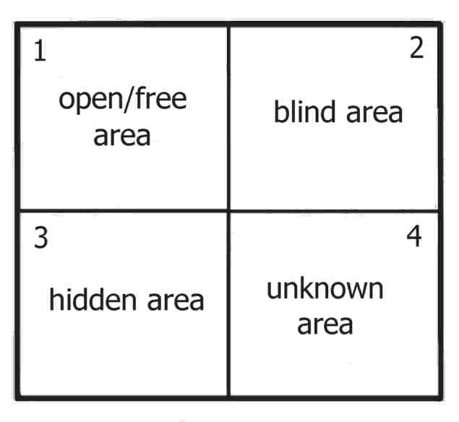
The Johari Window Exercise
1.

2.

3.

4. You can’t fill this one out… It’s unknown
