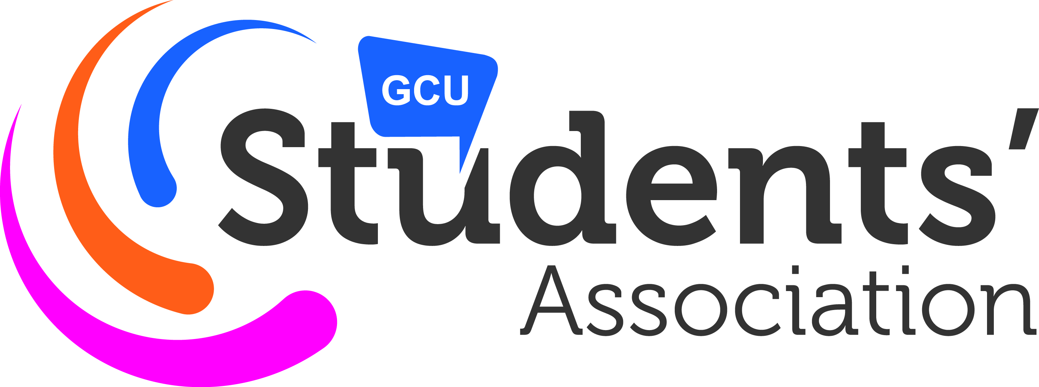
Equality & Diversity Committee
9th October 2018 (14:00 – 15:00) in NH209
Present:
Yetunde Ogedengbe, VP SHLS (Chair)
Nicole Kusel –McCrory, LGBT+ Officer
Sarah Cullen, Women’s Officer
Monica Allen, E & D Societies Champion
Apologies:
Tara Campbell, International Officer
Valeri Vasilev, Disability Officer
Racheal Olayinka, BME Officer
Daniel Villafrance, E &D Sports Champion
Fraser Knight, LGBT+ Deputy Officer
Susan Docherty, Women’s Deputy Officer

Absent:
Lauren Baigrie, Student Carers’ Officer
Helen Johnston, Care Experienced Officer

In Attendance:
Sara MacLean, Student Voice Team Leader (clerk)
Adrian Lui, GCU Equalities and Diversity Manager
Caroline Miller, Representation and Advice Manager
Annabelle Njenga – GCU Alumnus

- Apologies
As detailed above.
- Minutes from last meeting
Minutes of the 11 April 2018 meeting were approved.
- Matters arising
No outstanding matters
- Campaign and Joint working
Chair moved the discussion and campaign and joint working discussion to the beginning of the meeting and introduced AN, a GCU alumnus. AN introduced a possible campaign and opportunity for joint working called Black Feminist and Friends (BFF). The rationale behind BFF is to increase peer support, mentoring and networking for black women although the group would be open to all. The committee were happy to support the group but felt that they might be more sustainable as a society.

- Men’s Health and Alliance Group
Chair moved the discussion on the Men’s Health and Alliance Group to the beginning of the meeting. YO explained that the proposed group would be a representation and not a liberation group. The remit of the group would be to support and promote men’s health campaigns and collaborate with other liberation and representation groups. The officer of the proposed group would sit on the E & D committee. Committee asked for clarification on how this would be different from the mental health society. YO explained that it would be on all health issues, not just mental health and also include the remit of acting as an ally for other liberation/representation groups. The committee voted on backing the group as it went to Student Voice. Outcome of non-binding vote: 4 in favour; 0 not in Favour; 0 abstentions.

- Introductions
The Committee discussed the composition of the group. The previous discussion on the Men’s Health and Alliance group had already agreed to expand the membership of the committee to include the officer of the group. It was further discussed to include the Mature and Part- Time Students Officer as age is a protected characteristic under E & D legislations. The committee voted on backing the expansion of the committee to include the Mature and part-time students’ officer. Outcome of vote: 4 in favour; 0 not in Favour; 0 abstentions.

The chair raised on-going efforts to help revitalise the international student group. The chair proposed that the membership of the international committee should be revised. Currently the committee membership is ‘students from each school’, the chair proposed to revise the committee membership to representatives of international based societies and representatives of INTO students. The committee held a vote on changing the committee membership of the international students in the byelaws. Outcome of vote: 4 in favour; 0 not in Favour; 0 abstentions.
Action: YO to work with societies E & D Champion and Societies Policy Lead to contact international students societies.

- Anti-Bullying Policy Draft Discussion
Committee discussed rationale for the policy and the current state of anti-bullying mechanisms within the university and the Students’ Association.
Action: YO to consult SAGE on anti-bullying draft
Action: YO to draft a policy and bring back to next E & D committee meeting for further consultation

- Healthy Body Healthy Mind
Chair updated committee on the Students’ Associations ongoing work to obtain the Healthy Body/Healthy Mind accreditation..

- Officer Updates

LGBT+

Group will be holding a vigil on the main concourse for the Trans Awareness day. Group is currently discussing a charity event for Rape Crisis.

Women’s

Currently focusing on recruiting more members by hosting a doc screening/ meet and eat. The group are considering joint working with Ethical and Environmental and with LGBT+ on trans awareness and hosting NUS women’s workshops.
Action: YO to make a flyer and send out to students’ association women’s list about the film/meet and eat.

- GCU Equality and Diversity Update

GCU will be piloting an intercultural competence in a number of courses across the three schools with the aim to embed it into year one for all courses in 2019-20.

- AOCB

Action: SM will compile dates for NUS liberation conferences and distribute.

