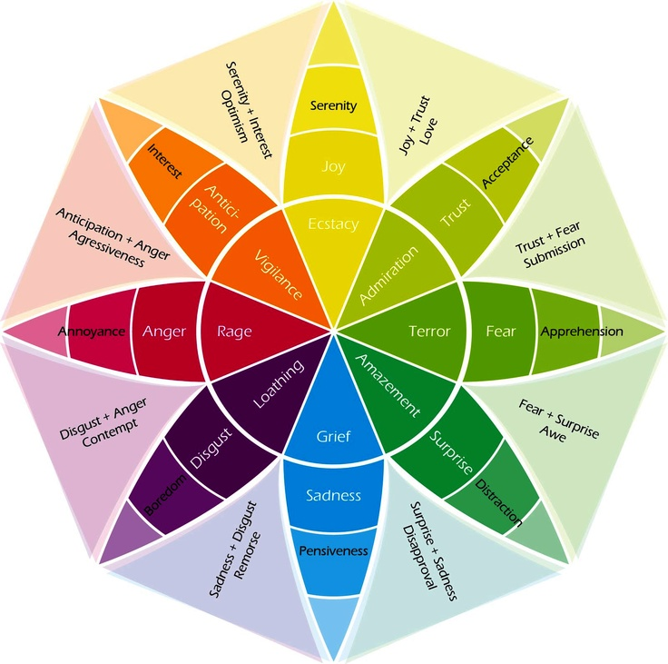
The Wheel of Emotion
The Wheel of Emotion Key

Second circle The 8 core emotions
Towards centre of the circle Emotions Intensify
Towards edges of the circle Emotions decrease
In between each sections Emotions which are a mixture of two core emotions

The Wheel of Emotion was designed by Dr Robert Plutchik in 1980 and he proposed there were 8 core emotions which the rest of our emotions stem from. By using the wheel, we can learn how to identify different emotions and act accordingly.

